### Module 01

**Aim** : Study of NIST model of cloud computing

**Objective:** Understand deployment models, service models, advantages of cloud computing.

# Theory:

Cloud computing is a model for enabling convenient, on-demand network access to a shared pool of configurable computing resources (e.g., networks, servers, storage, applications, and services) that can be rapidly provisioned and released with minimal management effort or service provider interaction.

This cloud model is composed of five essential characteristics, three service models, and four deployment models.

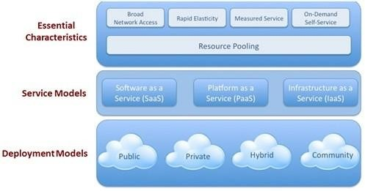

Figure 1.1 Cloud model

### Essential Characteristics:

1. On-demand self-service. A consumer can unilaterally provision computing capabilities, such as server time and network storage, as needed automatically without requiring human interaction with each service’s provider.
2. Broad network access. Capabilities are available over the network and accessed through standard mechanisms that promote use by heterogeneous thin or thick client platforms (e.g., mobile phones, tablets, laptops, and workstations).
3. Resource pooling. The provider’s computing resources are pooled to serve multiple consumers using a multi-tenant model, with different physical and virtual resources dynamically assigned and reassigned according to consumer demand. There is a sense of location independence in that the customer generally has no control or knowledge over the exact location of the provided resources but may be able to specify location at a higher level of abstraction (e.g., country, state, or data center). Examples of resources include storage, processing, memory, and network bandwidth.
4. Rapid elasticity. Capabilities can be rapidly and elastically provisioned, in some cases automatically, to scale rapidly outward and inward commensurate with demand. To the consumer, the capabilities available for provisioning often appear to be unlimited and can be appropriated in any quantity at any time.
5. Measured Service. Cloud systems automatically control and optimize resource use by leveraging a metering capability1 at some level of abstraction appropriate to the type of service (e.g., storage, processing, bandwidth, and active user accounts). Resource usage can be monitored, controlled, and reported, providing transparency for both the provider and consumer of the utilized service.

### Service Models:

1. Cloud Software as a Service (SaaS).

The capability provided to the consumer is to use the provider’s applications running on a cloud infrastructure. The applications are accessible from various client devices through a thin client interface such as a Web browser (e.g., Web-based email), or a program interface. The consumer does not manage or control the underlying cloud infrastructure including network, servers, operating systems, storage, or even individual application capabilities, with the possible exception of limited user-specific application configuration settings.

1. Cloud Platform as a Service (PaaS).

The capability provided to the consumer is to deploy onto the cloud infrastructure consumer-created or -acquired applications created using programming languages and

tools supported by the provider. The consumer does not manage or control the underlying cloud infrastructure including network, servers, operating systems, or storage, but has control over the deployed applications and possibly application hosting environment configurations.

1. Cloud Infrastructure as a Service (IaaS).

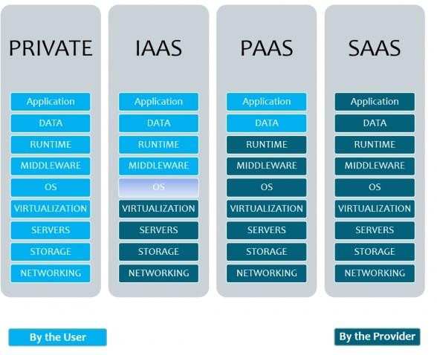The capability provided to the consumer is to provision processing, storage, networks, and other fundamental computing resources where the consumer is able to deploy and run arbitrary software, which can include operating systems and applications. The consumer does not manage or control the underlying cloud infrastructure but has control over operating systems, storage, deployed applications; and possibly limited control of select networking components (e.g., host, firewalls).

Figure 1.2 Cloud Service Model

### Deployment Models:

1. Private cloud. The cloud infrastructure is provisioned for exclusive use by a single organization comprising multiple consumers (e.g., business units). It may be owned, managed, and operated by the organization, a third party, or some combination of them, and it may exist on or off premises.
2. Community cloud. The cloud infrastructure is provisioned for exclusive use by a specific community of consumers from organizations that have shared concerns (e.g., mission, security requirements, policy, and compliance considerations). It may be

owned, managed, and operated by one or more of the organizations in the community, a third party, or some combination of them, and it may exist on or off premises.

1. Public cloud. The cloud infrastructure is provisioned for open use by the general public. It may be owned, managed, and operated by a business, academic, or government organization, or some combination of them. It exists on the premises of the cloud provider.
2. Hybrid cloud. The cloud infrastructure is a composition of two or more distinct cloud infrastructures (private, community, or public) that remain unique entities, but are bound together by standardized or proprietary technology that enables data and application portability (e.g., cloud bursting for load balancing between clouds)."

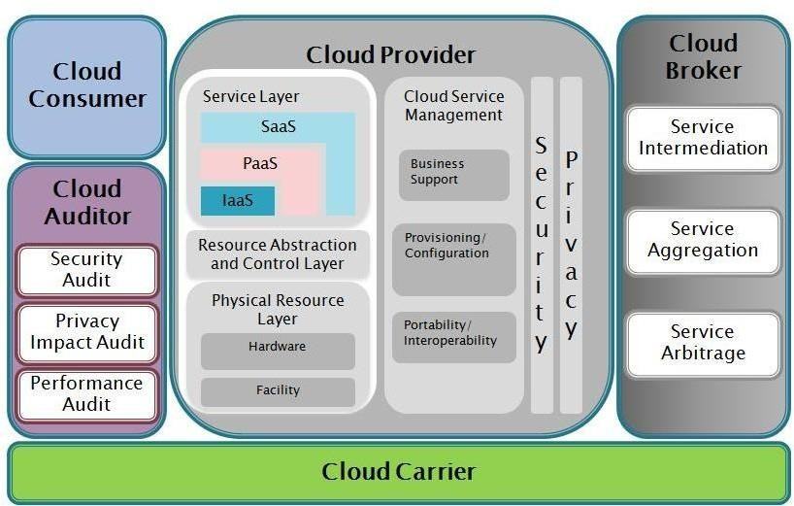

Figure 1.3 NIST Reference Architecture of Cloud Computing

# Conclusion:

The highlights of cloud, the administrations gave by it shows that the distributed computing is profoundly dependable figuring worldview where the customer can utilize an enormous measure of processing assets according to his/her interest without really claiming it.

**Program Documentation Punctuality Viva Answer Experiment Teacher Execution/ (02) (01) (05) Marks (15) Signature formation/ with date**

|  |  |  |  |  |  |
| --- | --- | --- | --- | --- | --- |
| **Program Execution/ formation/ correction/ ethical practices**  **(07)** | **Documentation (02)** | **Punctuality (01)** | **Viva Answer (05)** | **Experiment Marks (15)** | **Teacher Signature with date** |
|  |  |  |  |  |  |

5

11

# Output

**Definition:**

Cloud computing is the on−demand availability of computer system resources. Cluster computing connects different computers in a single location via LAN to work as a single computer. The term cloud refers to a network or the Internet. It gives a solution for infrastructure at low cost. Cloud server maintains all the processing and storage.

# Features of Cloud Computing:

**High scalability -** It means on demand provisioning of resources on a large scale without requiring human interaction with each service provider. High availability and reliability − Availability of servers is more reliable and high because it minimizes the chances of infrastructure failure.

**Agility -** It shares the resources between users and works very quickly.

**Multi-sharing -** Multiple users and applications work more efficiently with less cost by sharing common infrastructure using cloud computing.

**Maintenance -** Maintenance of cloud computing applications is easier as they are not required to be installed on each computer and can also be accessed from various places, ultimately reducing the cost.

**Low cost -** It is cost effective because the company no more needs to set its own infrastructure. It pays according to resources it has consumed.

**Services in pay-per-use mode -** APIs(Application Programming Interfaces) are provided to the usersfor accessing the services on the cloud andpayaccording touse of the service.

# Types of Cloud Computing Services:

### Infrastructure as a Service (IaaS):

IaaS is a cloud computing model where virtualized infrastructure is offered to, and managed for, businesses by external cloud providers. With IaaS, companies can outsource for storages, servers, data center space and cloud networking components connected through the internet, offering similar functionality as that ofanon−premises infrastructure. Some examples of the wide usage of IaaS are automated, policy−driven operations such as backup, recovery, monitoring, clustering, internal networking, website hosting, etc. The service provider is responsible for building the servers and storage, networking firewallsƒ security, and the physical data center. Some key players offering IaaS are Amazon EC2, Microsoft Azure, Google Cloud Platform, GoGrid, Rackspace, DigitalOcean among others.

### Platform as a Service (PaaS):

PaaS builds on IaaS. Here, cloud vendors deliver computing resources, both cloud software and hardware infrastructure components like middleware and operating systems, required to develop and test applications. The PaaS environment enables cloud users (accessing them via a webpage) to install and host data sets, development tools and business analytics applications, apart from building and maintaining necessary hardware. Some key players offering PaaS are Bluemix, CloudBees, Salesforce.com, Google App Engine, Heroku, AWS, Microsoft Azure, OpenShift, Oracle Cloud, SAP and OpenShift.

### Software as a Service (SaaS):

SaaS is special in that it incorporates both IaaS and Paas. Here, the cloud service provider delivers the entire software suite as a pay−per−use model. SaaS lets users easily access software applications such as emails −− over the internet. Most common examples of SaaS are Microsoft Office 360, AppDynamics, Adobe Creative Cloud, Google G Suite, Zoho, Salesforce, Marketo, Oracle CRM, Pardot Marketing Automation, and SAP Business ByDesign.

# Types of Cloud Deployments:

There are three types of cloud deployments categorized based on an organization’s ability to manage and secure assets as well as business needs.

### Public Cloud:

Public cloud, in general, is SaaS services offered tousers over the internet. It is the most economical option for users in which the service provider bears the expenses of bandwidth and infrastructure.

### Private Cloud:

As the name suggests, the private cloud is used by large organizations to build and manage their own data centers for specific business and IT needsƒ operations. The private cloud provides more control over customizability, scalability and flexibility.

### Hybrid cloud:

Hybrid cloud is the combination of a private and public cloud, providing for more flexibility to businesses while having control over critical operations and assets, coupled with improved flexibility and cost efficiency.

# Architecture:

The broad divisions of cloud architecture are: Front Side and Back Side

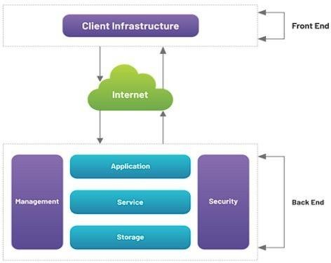

### Front Side:

It is a term used to denote any user−facing part of cloud computing architecture. This is the part that the end user interacts with, and it consists of subcomponents that make up the user experience.

### Front end architecture is made up of three parts:

**Software**

Front end software architecture includes the software that allows cloud computing software to be run from the user’s side.

### User Interface

The user interface is what the end user directly interacts with in order to perform tasks on the cloud.

### Client Device/Network

The client−side device or network is an integral part of front−end architecture. This includes client−side hardware such as the user’s PC and input devices.

### Back Side

Back end architecture is the part of the cloud computing architecture that powers the front−end architecture.

# Application:

The application component of the back−end cloud software architecture generally refers to the interface being offered to the end user, except on the side of the server.

### Service

This is where all the magic happens. The service is directly responsible for providing the utility in the architecture.

### Cloud Runtime

The cloud runtime is where the service runs. It is similar to an operating system in the cloud, with technologies such as virtualization allowing multiple runtimes to exist on the same server.

### Storage

As the name suggests, storage is where all the data required tooperate the cloud software resides.

### Infrastructure

The infrastructure is the engine powering all cloud software services. This includes computing components such as the Central Processing Unit (CPU), Graphics Processing Unit (GPU), motherboard and all the other components required for the system to function smoothly, like network cards and additional specific accelerator cards for special use−cases.

### Conclusion

In this manner we have leant about what is distributed computing. The term cloud alludes to a system or the Internet. It gives an answer for framework requiring little to no effort. Cloud server keeps up all the handling and capacity. Just as we have learned about utilization of distributed computing , its engineering and various sorts of administration gave by cloud.

# Module 02

**Aim** : Virtualization in Cloud- Creating and running virtual machines..

**Objective:** To learn different types of virtualizations, Host and bare metal hypervisors and implement horizontal scalability.

**Technology:** XEN/ Vmwares EXSi

### Hosted Virtualization on Oracle Virtual Box Hypervisor Hosted Virtualization on KVM Hypervisor

**Theory:**

In computing, virtualization refers to the act of creating a virtual (rather than actual) version of something, including virtual computer hardware platforms, operating systems, storage devices, and computer network resources.

### Why is virtualization useful?

The techniques and features that VirtualBox provides are useful for several scenarios:

* + - **Running multiple operating systems simultaneously.** VirtualBox allows you to run more than one operating system at a time. Since you can configure what kinds of "virtual" hardware should be presented to each such operating system, you can install an old operating system such as DOS or OS/2 even if your real computer's hardware is no longer supported by that operating system.
    - **Easier software installations.** Software vendors can use virtual machines to ship entire software configurations. For example, installing a complete mail server solution on a real machine can be a tedious task. With VirtualBox, such a complex setup (then often called an "appliance") can be packed into a virtual machine. Installing and running a mail server becomes as easy as importing such an appliance into VirtualBox.
    - **Testing and disaster recovery.** Once installed, a virtual machine and its virtual hard disks can be considered a "container" that can be arbitrarily frozen, woken up, copied, backed up, and transported between hosts. On top of that, with the use of another

VirtualBox feature called "snapshots", one can save a particular state of a virtual

machine and revert back to that state, if necessary. This way, one can freely experiment with a computing environment. If something goes wrong (e.g. after installing misbehaving software or infecting the guest with a virus), one can easily switch back to a previous snapshot and avoid the need of frequent backups and restores. Any number of snapshots can be created, allowing you to travel back and forward in virtual machine time. You can delete snapshots while a VM is running to reclaim disk space.

* + - **Infrastructure consolidation.** Virtualization can significantly reduce hardware and electricity costs. Most of the time, computers today only use a fraction of their potential power and run with low average system loads. A lot of hardware resources as well as electricity is thereby wasted. So, instead of running many such physical computers that are only partially used, one can pack many virtual machines onto a few powerful hosts and balance the loads between them.

### Hypervisor

A hypervisor or virtual machine monitor (VMM) is a piece of computer software, firmware or hardware that creates and runs virtual machines. It allows multiple operating systems to share a single hardware host. Each operating system appears to have the host's processor, memory, and other resources all to itself. However, the hypervisor is actually controlling the host processor and resources, allocating what is needed to each operating system in turn and making sure that the guest operating systems (called virtual machines) cannot disrupt each other.

There are two types of hypervisors: Type 1 and Type 2.

* + - Type 1 hypervisor (also called a bare metal hypervisor) is installed directly on physical host server hardware just like an operating system. Type 1 hypervisors run on dedicated hardware. They require a management console and are used in data centers. Examples include Oracle OVM for SPARC, ESXi, Hyper-V and KVM.
    - Type 2 hypervisors support guest virtual machines by coordinating calls for CPU, memory, disk, network and other resources through the physical host's operating system. This makes it easy for an end user to run a virtual machine on a personal computing device. Examples include VMware Fusion, Oracle Virtual Box, Oracle VM for x86, Solaris Zones, Parallels and VMware Workstation.

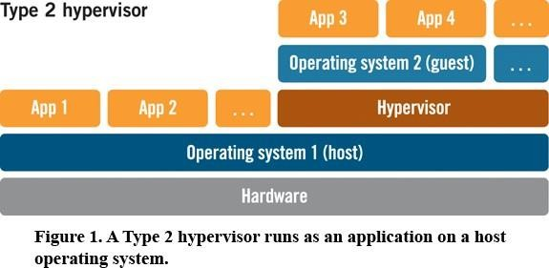

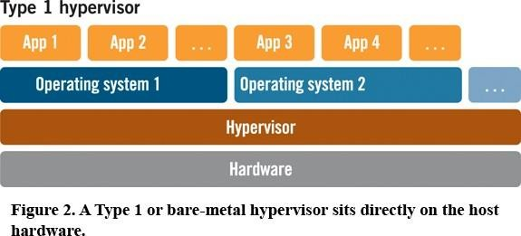

### Terminology

Host operating system (host OS).

This is the operating system of the physical computer on which VirtualBox was installed. There are versions of VirtualBox for Windows, Mac OS X, Linux and Solaris hosts.

Guest operating system (guest OS).

This is the operating system that is running inside the virtual machine. Theoretically, VirtualBox can run any operating system (DOS, Windows, OS/2, FreeBSD, OpenBSD).

Virtual machine (VM).

This is the special environment that VirtualBox creates for your guest operating system while it is running. In other words, you run your guest operating system "in" a VM. Normally, a VM will be shown as a window on your computer's desktop, but depending on which of the various frontends of VirtualBox you use, it can be displayed in full screen mode or remotely on another computer.

In a more abstract way, internally, VirtualBox thinks of a VM as a set of parameters that determine its behavior. They include hardware settings as well as state information. These settings are mirrored in the VirtualBox Manager window as well as the VBoxManage command line program.

Guest Additions.

This refers to special software packages which are shipped with VirtualBox but designed to be installed *inside* a VM to improve performance of the guest OS and to add extra features.

# Procedure :

### Hosted Virtualization on Oracle Virtual Box Hypervisor

Step 1: Download Oracle Virtual box from <https://www.virtualbox.org/wiki/Downloads>

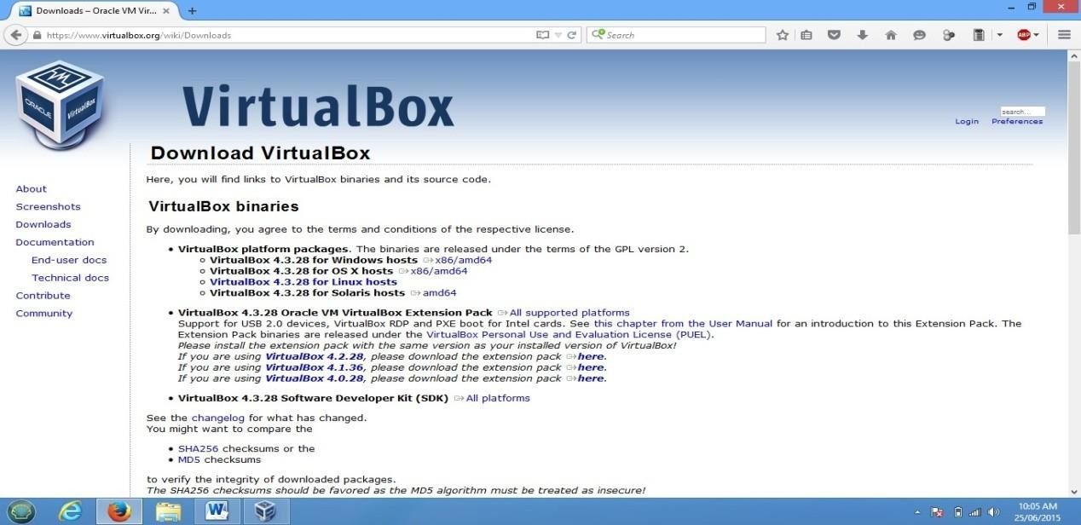

Step 2: Install it in Windows, Once the installation has done open it.

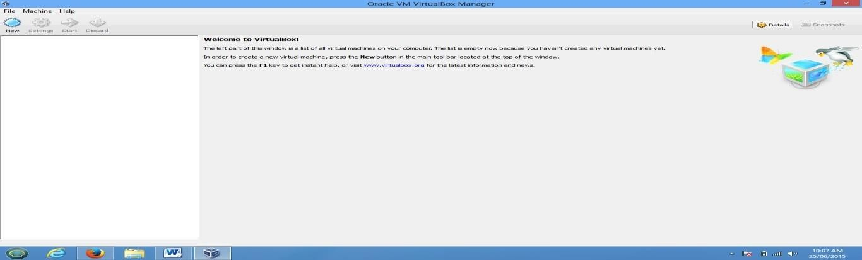

Step 3:-: Create Virtual Machine by clicking on New

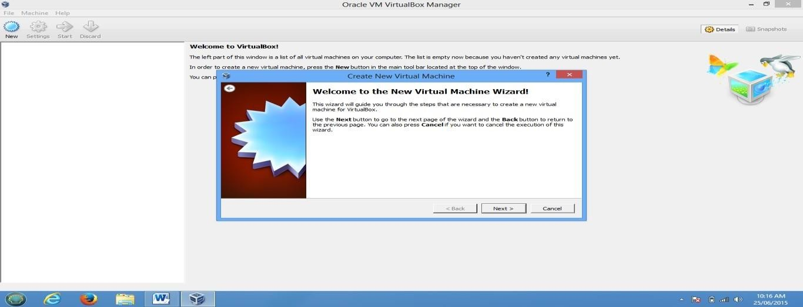

Step 4-: Specify RAM Size, HDD Size, and Network Configuration and Finish the wizard

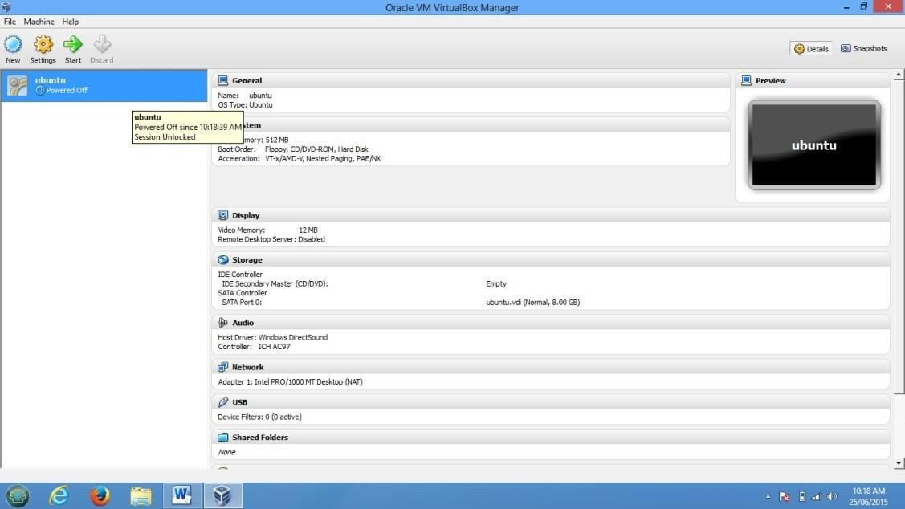

Step 5-: To Select the media for installation Click on start and browse for iso file

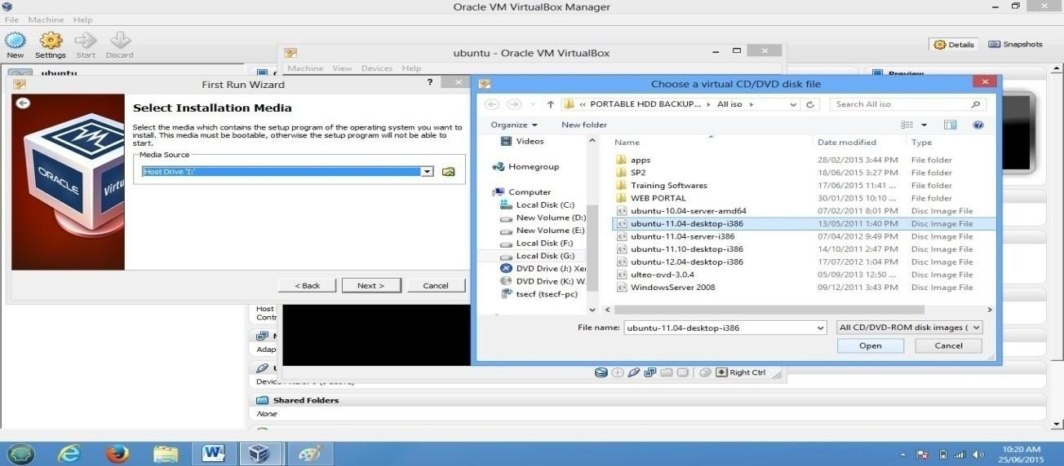

Step 6:Complete the Installation and use it.

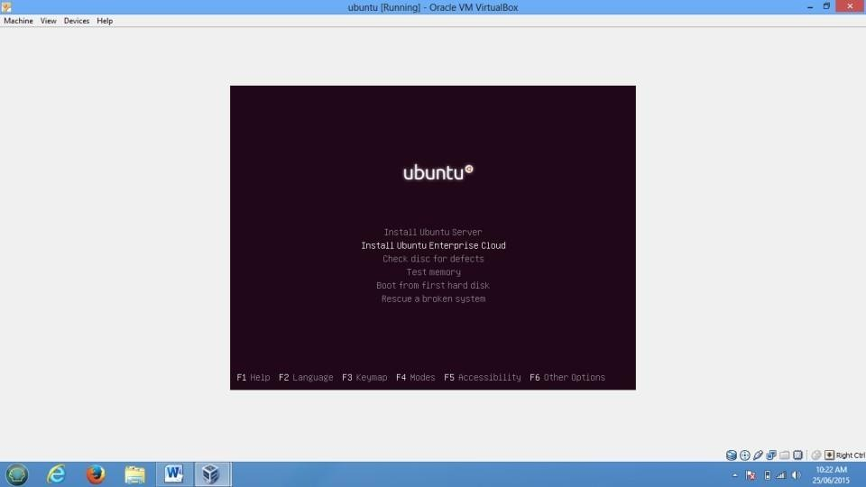

Step 7: To Connect OS to the network change network Mode to Bridge Adaptor

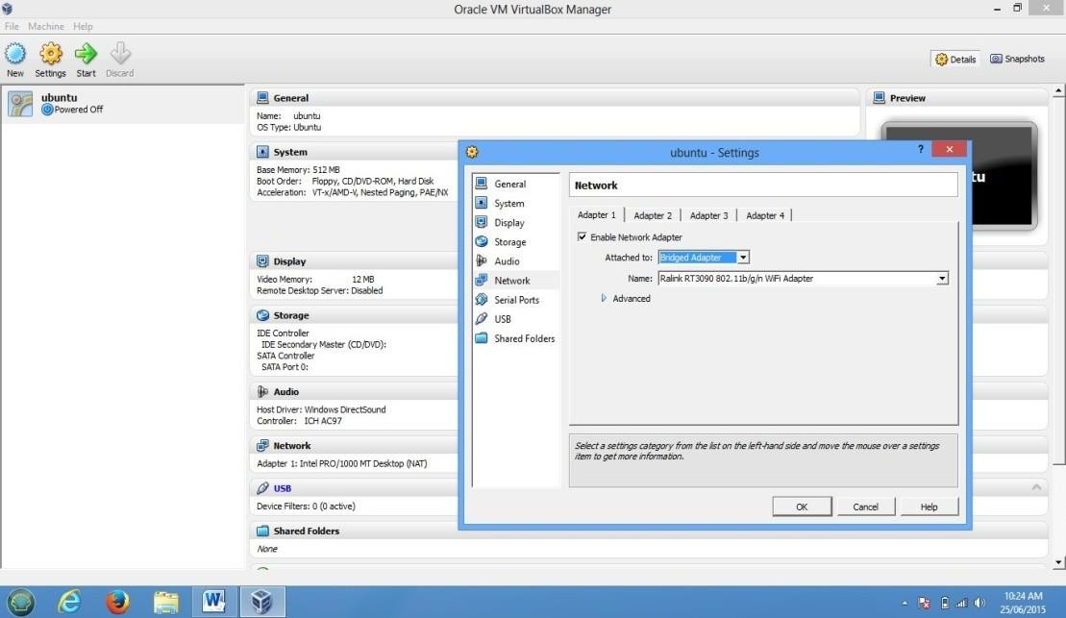

### Hosted Virtualization on KVM Hypervisor

The Steps to Create and run Virtual machines in KVM are as follows

* 1. Check whether CPU has hardware virtualization support.

KVM only works if your CPU has hardware virtualization support – either Intel VT-x or AMD-V. To determine whether your CPU includes these features, run the following command:

### #sudo grep -c "svm\|vmx" /proc/cpuinfo

A 0 indicates that your CPU doesn’t support hardware virtualization, while a 1 or more indicates that it does.

* 1. Install KVM and supporting packages.

Virt-Manager is a graphical application for managing your virtual machines.you can use the kvm command directly, but libvirt and Virt-Manager simplify the process.

### #sudo apt-get install qemu-kvm libvirt-bin bridge-utils virt-manager

* 1. Create User.

Only the root user and users in the libvirtd group have permission to use KVM virtual machines. Run the following command to add your user account to the libvirtd group:

### #sudo adduser sakec

**#sudo adduser sakec libvirtd**

After running this command, log out and log back in as sakec

* 1. Check whether everything is working correctly.

Run following command after logging back in as sakec and you should see an empty list of virtual machines. This indicates that everything is working correctly.

### #virsh -c qemu:///system list

* 1. Open Virtual Machine Manager application and Create Virtual Machine

### #virt-manager

* 1. Create and run Virtual Machines

PART II

Creating and running virtual machines on Bare-Metal Hypervisor Xen Server.

Step 1: Install Xen Server

Step i-: Insert Bootable Xen Server CD into CDROM and Make first boot device as a CDROM from BIOS

Step ii-: press F2 to see the advanced options, otherwise press Enter to start installation Step iii -: Select Keyboard Layout

Step iv -:Press Enter to load Device Drivers

Step v -:Press Enter to Accept End user license Agreement

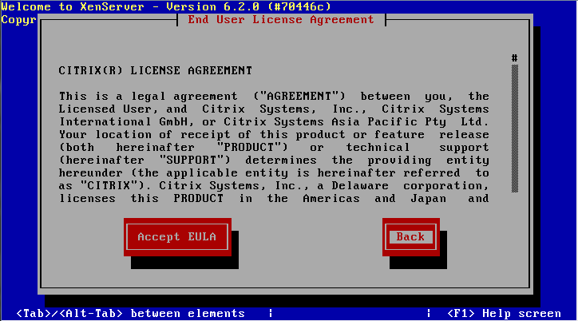

Step vi -:Select Appropriate disk on which you want to install Xen server

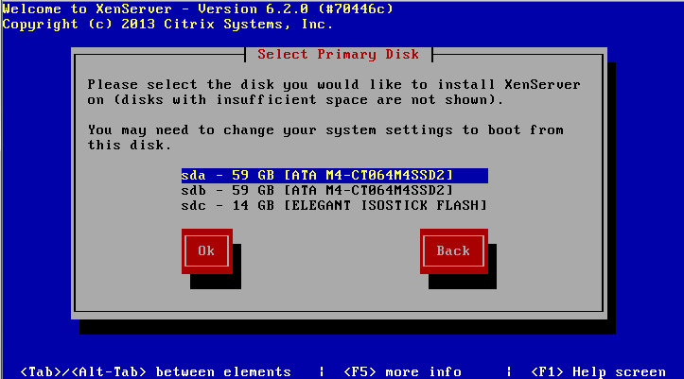

Step vii -:Select Appropriate installation Media (LOCAL Media) Step viii -:Select Additional Packages for installation Step ix-: Specify Root password

Step x -: Specify IP Address to a Xen Server Step xi-:Select Time Zone

Step xii-:Specify NTP Servers address or use manual time entry then start installation.

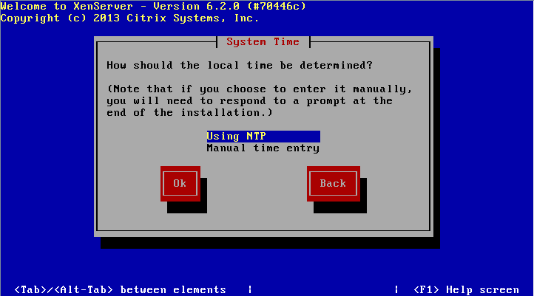

Once installation is done you will see the final screen shown below.

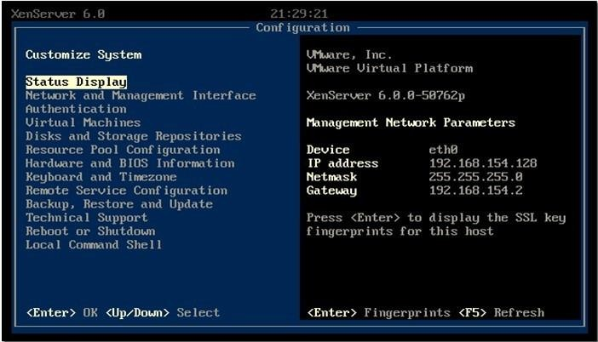

Xen Server Final Screenshot Step 2:Connect Xen Server to Xen Center

Firstly, download the xen center a management utily from xen server by opening the xen severs IP address as a URL on browser. Once Xen center is downloaded, install it.Open Xen center from start menu of Windows.

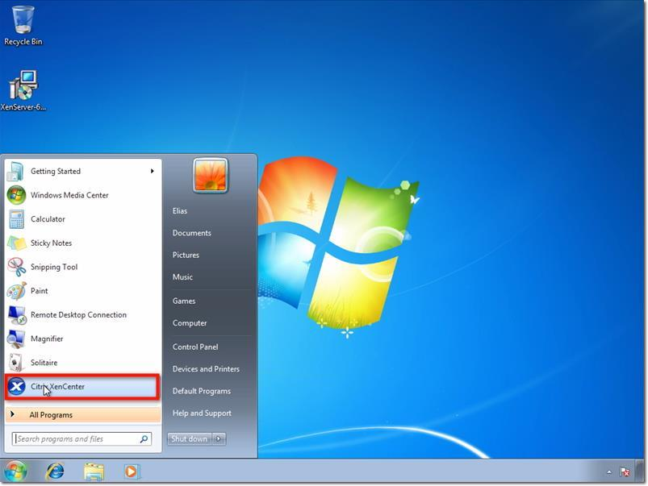

Here’s how XenCenter looks like (see screenshot below) before any hosts, resource pools, and so on, are added to it. To connect to the XenServer host you configured earlier, click Add a server.

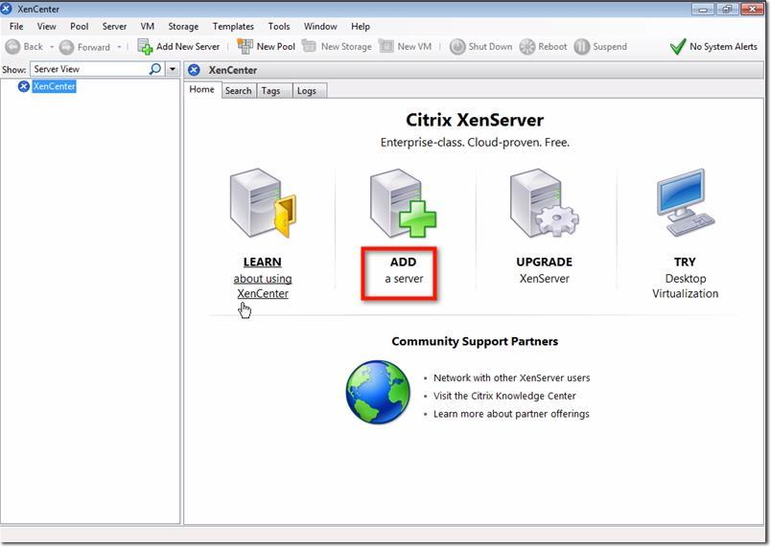

Enter the IP address I asked you to take note of earlier. Also enter the password you assigned for your root account. Click Add.

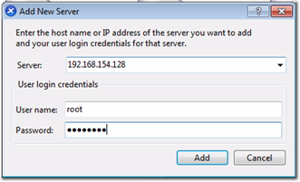

One of the first things you want to make sure as you’re adding a new XenServer to XenCenter is to save and restore the server connection state on startup. Check the box that will do just that.

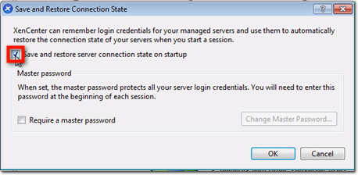

Once you do that, you will be allowed to configure a master password for all the XenServers you’ll be associating with this XenCenter. Click the Require a master password checkbox if that’s what you want to do, and then enter your desired master password in the fields provided.

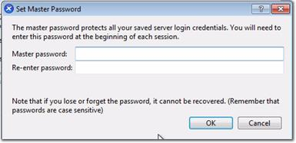

After you click OK, you’ll be brought back to the main screen, where you’ll see your XenServer already added to XenCenter.

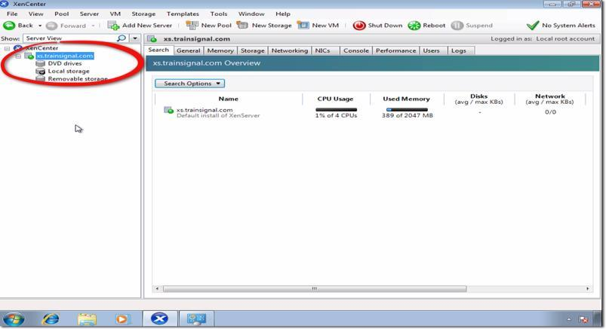

Step-:3 Create Storage Repository and Installing VM

Now Before Creating VM we have to Create Storage Repository first which is nothing but shared directory on Xen Center which holds all iso files and which is required to install Operating system on Xen Server its steps are as follows.Right click on Xenserver icon on xen center and click on New SR

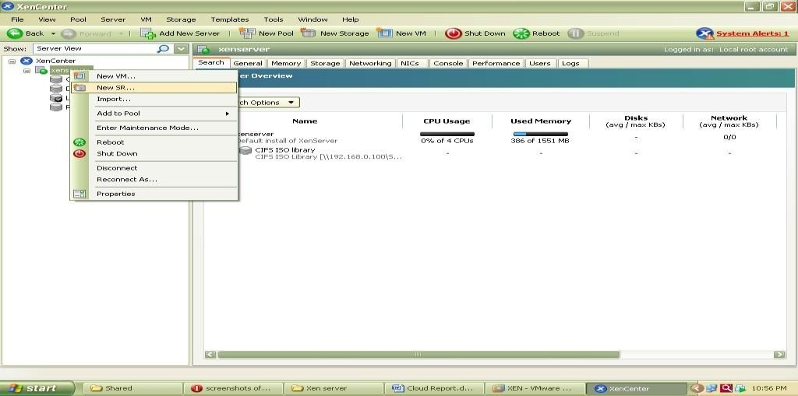

Now Select Windows CIFS library

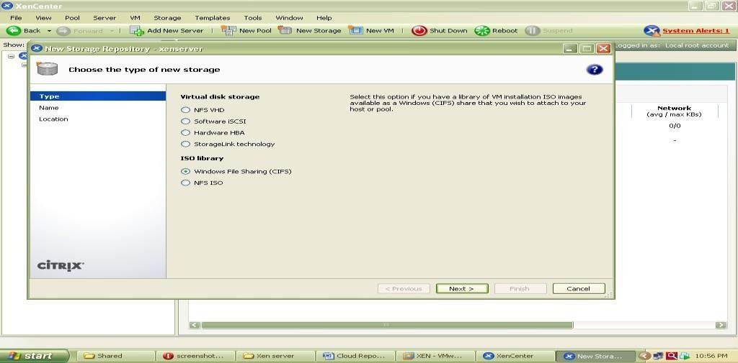

Specify Storage Repository Name

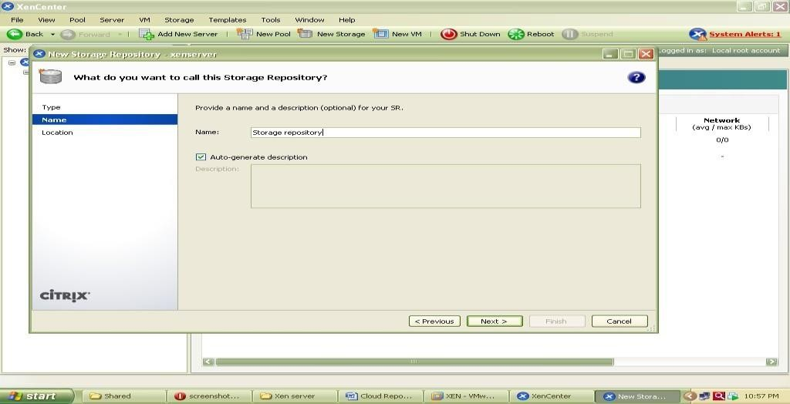

Now specify path of shared folder at client side which holds all iso files of os or VM which we are going to install on Xen Server.

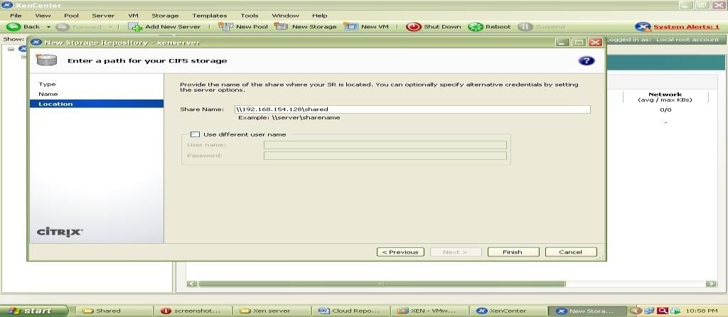

At the end Click on finish to create SR.

To check all iso files click on CIFS library and select storage this will show you all iso files.

### Installation of UBUNTU Server on Xen Server

Step 1 -: Right click on Xenserver icon on xen center and select New VM

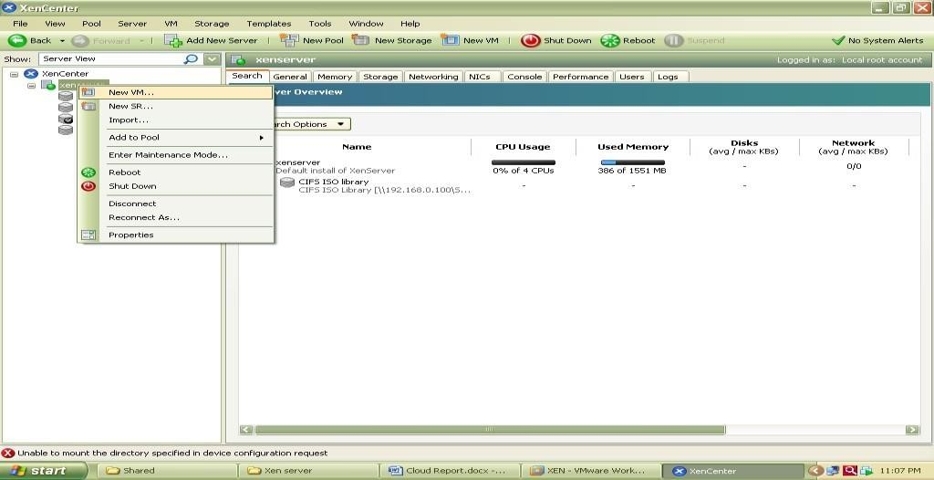

Now select an Operating System to be install here select Ubuntu Lucid Lynx and click on next

Now specify Instance Name as ubuntu server

Select iso file of Ubuntu server 10.10 to be install

Now select hardware for vm i.e. no. of cpu’s and memory

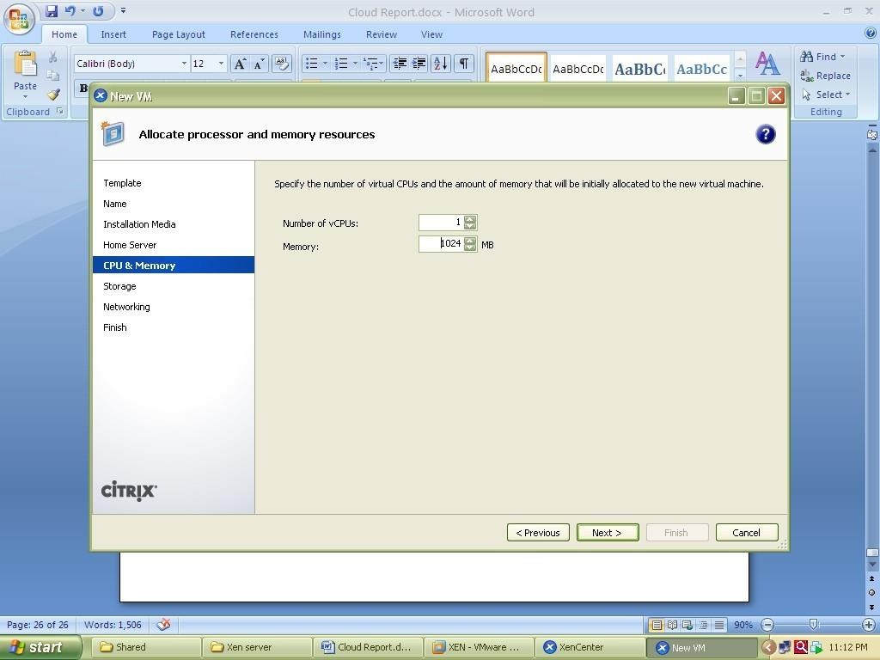

Select local storage

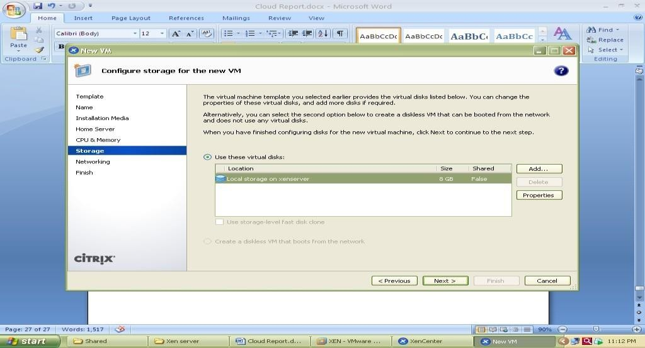

Select network

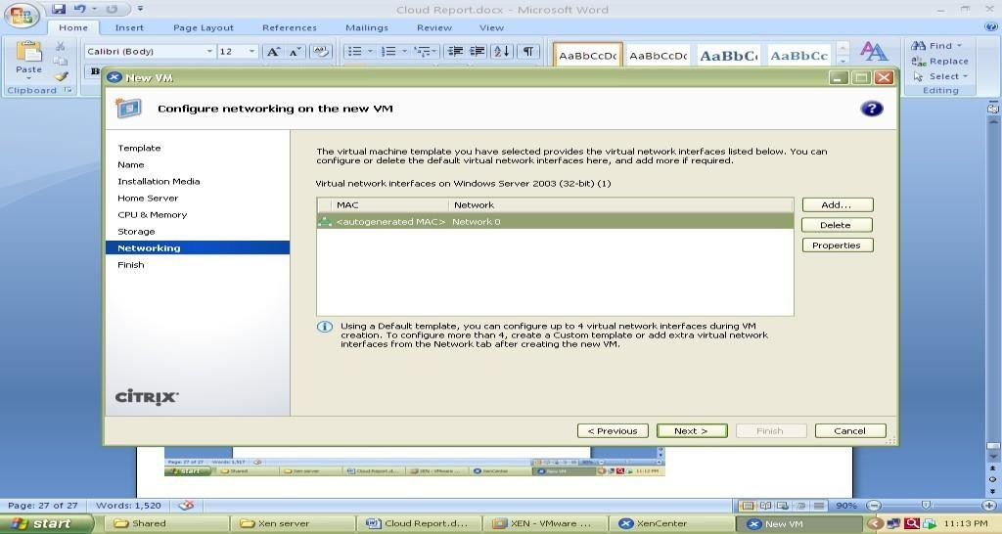

And click on finish

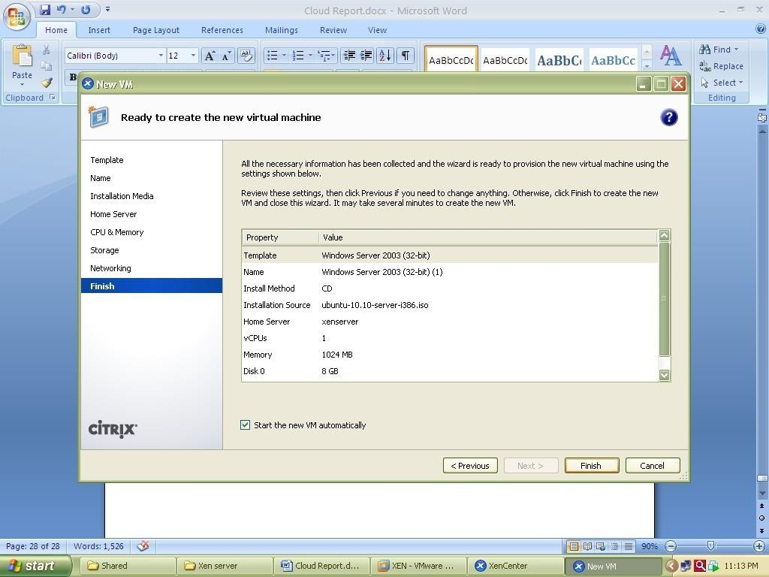

Now go to Console tab to install ubuntu and follow installation Steps.

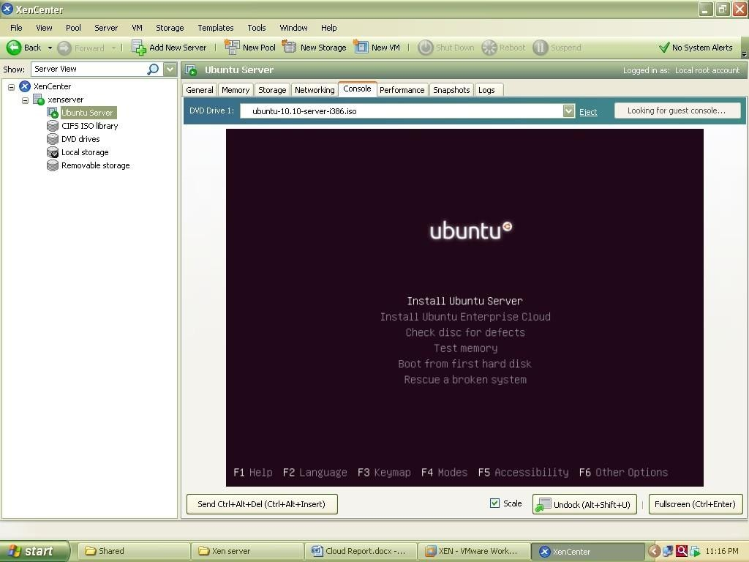

The Xen orchestra provides web based functionality of Xen Center.it provides access to all the VMs with their lifecycle management which are installed over Xen Server shown in figure

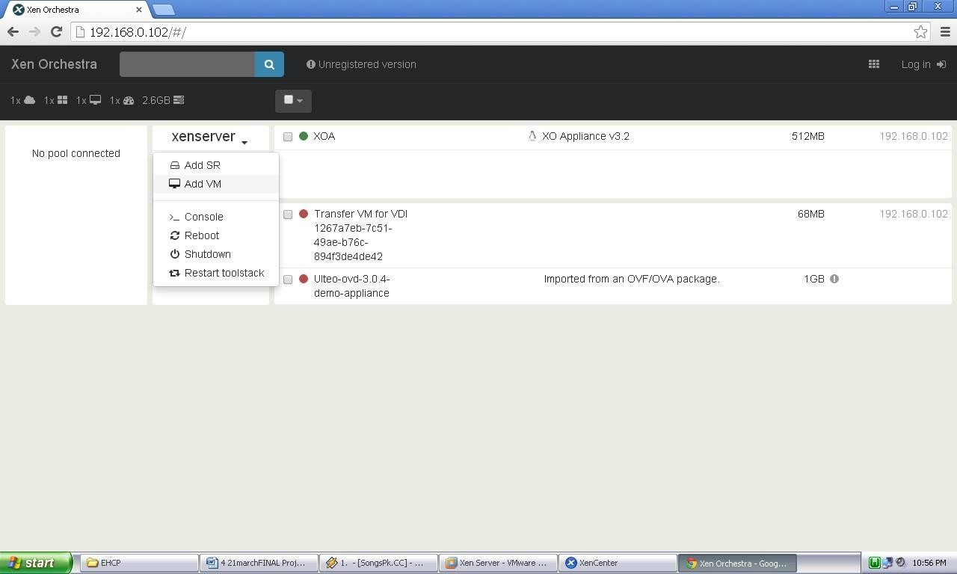

Xen Orchestra (XOA) Portal

The Windows XP image running on Xen Orchestra over Google chrome web browser is shown in following screenshot

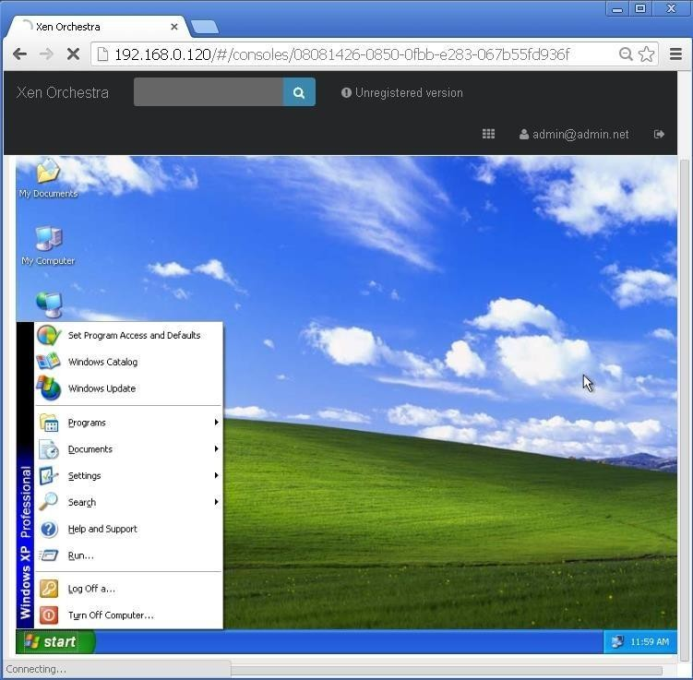

Windows XP running on Xen orchestra (XOA)

### CONCLUSION:

Type 1 hypervisor (likewise called an uncovered metal hypervisor) is introduced legitimately on physical host server equipment simply like a working framework. Type 1 hypervisors run on devoted equipment. They require an administration comfort and are utilized in server farms. Models incorporate Oracle OVM for SPARC, ESXi, Hyper-V and KVM. Type 2 hypervisors bolster visitor virtual machines by planning calls for CPU, memory, plate, organize and different assets through the physical host's working framework. This makes it simple for an end client to run a virtual machine on an individualized computing gadget. Models incorporate VMware Fusion, Oracle Virtual Box and so forth.

|  |  |  |  |  |  |
| --- | --- | --- | --- | --- | --- |
| **Program Execution/ formation/ correction/ ethical practices**  **(07)** | **Documentation (02)** | **Punctuality (01)** | **Viva Answer (05)** | **Experiment Marks (15)** | **Teacher Signature with date** |
|  |  |  |  |  |  |

# Output

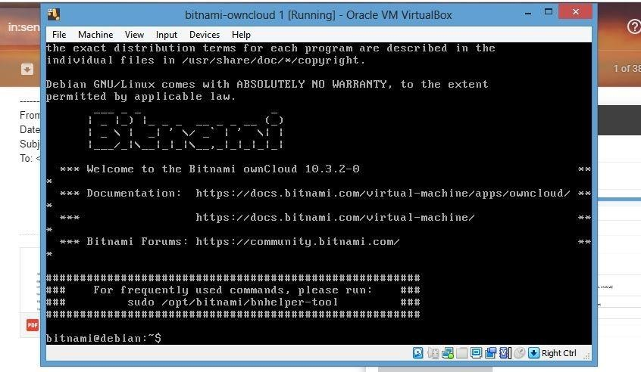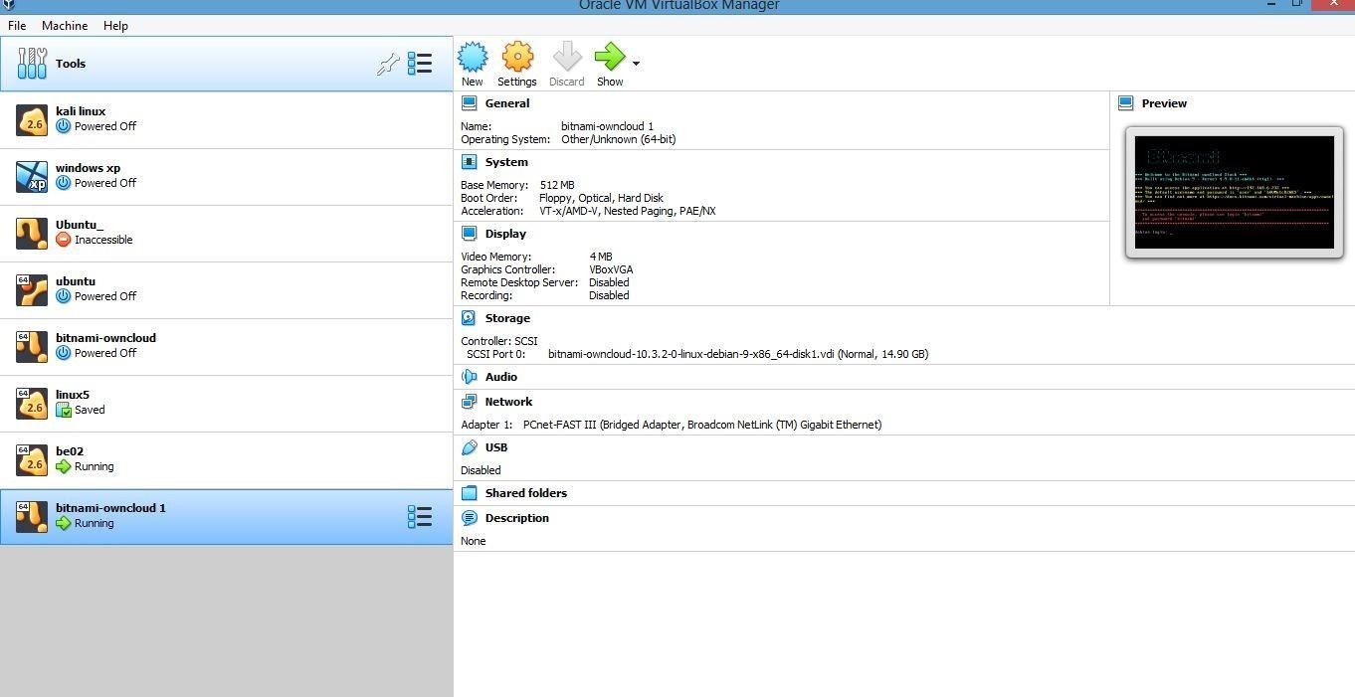

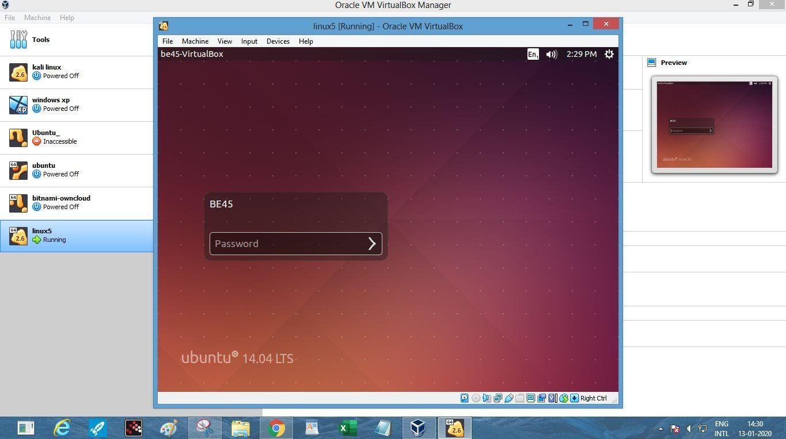

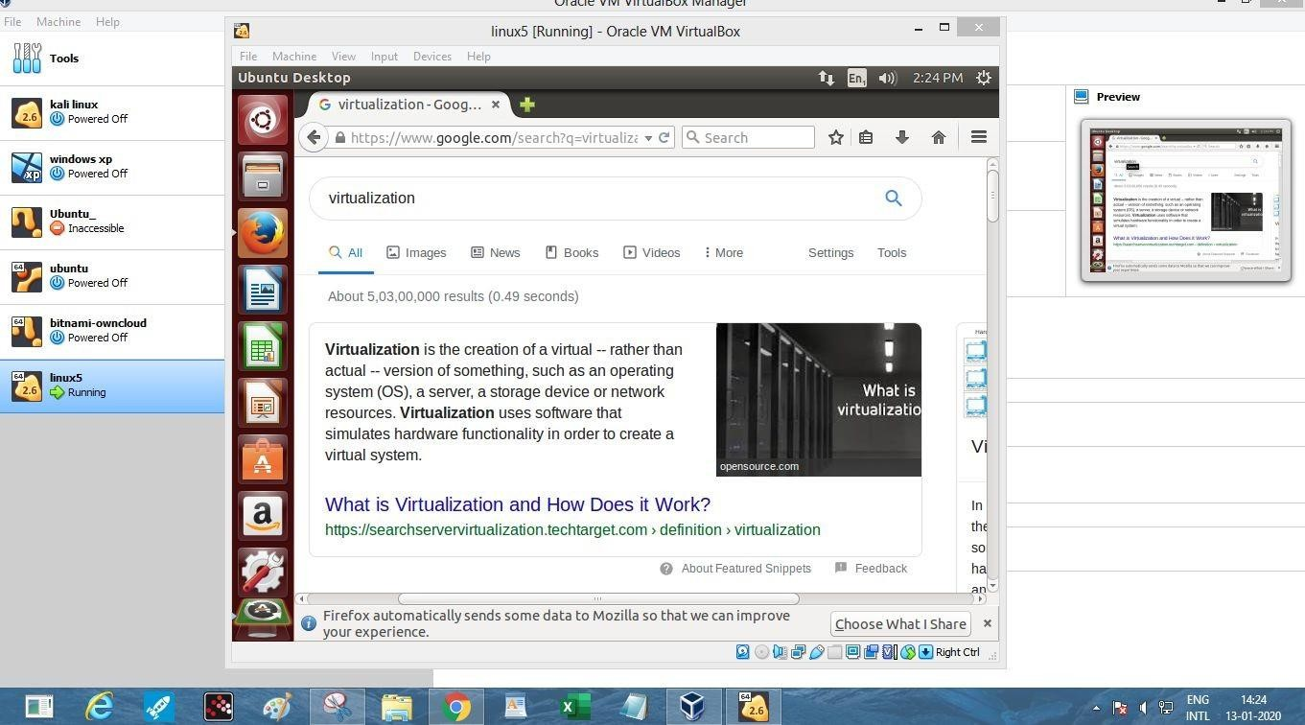

**Conclusion**

In this test we have found out about Virtualization. It alludes to the demonstration of making a virtual form of something, including virtual PC equipment stages, stockpiling gadgets, and PC organize assets.

Here we have introduced Ubuntu working framework on virtual box. Just as we have leant about kinds of hypervisor. Type 1 hypervisor is introduced straightforwardly on physical host server equipment simply like a working framework. Type 1 hypervisors run on devoted equipment. Type 2 hypervisors bolster visitor virtual machines.

### Module 03

**Aim** : Implement Infrastructure as a Service **Objective:** Implement IaaS using your resources. **Technology:** Open Stack

# Theory:

DevStack Minimum Requirements

* + - Fresh installation of Ubuntu 18.04
    - Minimum memory of 4 GB
    - At least 2 vCPU
    - The storage capacity of 10 GB should be sufficient.
    - Internet connection
    - User with sudo

### Step 1: Update Ubuntu system

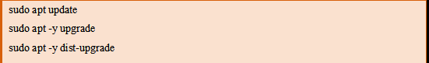Login to your Ubuntu system – Can be Desktop or VM in the Cloud and update it.

Reboot it after an upgrade.

### sudo reboot

**Step 2: Add Stack User**

Devstack should be run as a non-root user with sudo enabled. If you’re running your instance in the cloud, standard logins to cloud images such as “**centos**” or “**ubuntu**” or “**cloud-user**” are usually fine.

For other installations of Ubuntu 18.04, run the commands below to create DevStack deployment user.

### sudo useradd -s /bin/bash -d /opt/stack -m stack

Enable sudo privileges for this user without need for a password.

### echo "stack ALL=(ALL) NOPASSWD: ALL" | sudo tee /etc/sudoers.d/stack

Switch to stack user to test.

### jmutai@devstack:~$ sudo su - stack stack@devstack:~$ sudo su - root@devstack:~#

**Step 3: Download DevStack**

Clone Destack deployment code from Github.

### su - stack

**sudo apt -y install git**

**git clone https://git.openstack.org/openstack-dev/devstack** Create a local.conf file with 4 passwords and Host IP address. **cd devstack**

### nano

**local.conf** Add:

### [[local|localrc]]

**# Password for KeyStone, Database, RabbitMQ and Service ADMIN_PASSWORD=StrongAdminSecret DATABASE_PASSWORD=$ADMIN_PASSWORD RABBIT_PASSWORD=$ADMIN_PASSWORD SERVICE_PASSWORD=$ADMIN_PASSWORD**

**# Host IP - get your Server/VM IP address from ip addr command HOST_IP=192.168.10.100**

**Step 4: Start Openstack Deployment on Ubuntu 18.04 with DevStack** Now that you’ve configured the minimum required config to get started with DevStack, start the installation of Openstack.

### cd devstack

**./stack.sh**

DevStack will install;

* + - **Keystone** – Identity Service
    - **Glance** – Image Service
    - **Nova** – Compute Service
    - **Placement** – Placement API
    - **Cinder** – Block Storage Service
    - **Neutron** – Network Service
    - **Horizon** – Openstack Dashboard

This will take a 15 – 20 minutes, largely depending on the speed of your internet connection. At the end of the installation process, you should see output like this:

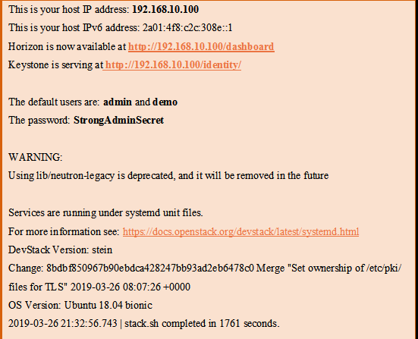

### Step 5: Access OpenStack Dashboard

Copy the Horizon URL shown on the installation output and paste it into your web browser:

[**http://192.168.10.100/dashboard**](http://192.168.10.100/dashboard)

Use the default users demo or admin and configured password to login.

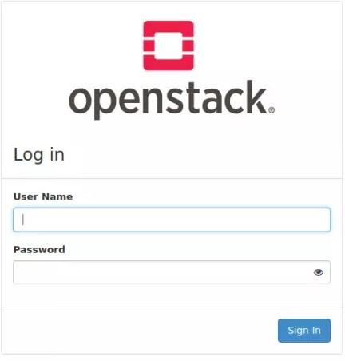

You should see Openstack Management Web console after logging in.

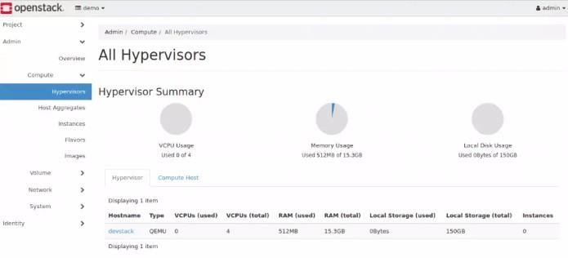

If you want to use Openstack command-line tool to manage your devstack. You’ve to source openrc in your shell.

### source openrc

You can now add instance images to Glance to use when creating Virtual Machines with Nova. We have a comprehensive guide on [Adding images to](https://computingforgeeks.com/adding-images-openstack-glance/) [Openstack Glance](https://computingforgeeks.com/adding-images-openstack-glance/).

*Adding Cirros Test Image*

Download Virtual Image.

**wge**[**t http://download.cirros-cloud.net/0.4.0/cirros-0.4.0-x86_64-disk.img**](http://download.cirros-cloud.net/0.4.0/cirros-0.4.0-x86_64-disk.img)

Upload it to Glance. openstack image create \

--container-format bare \

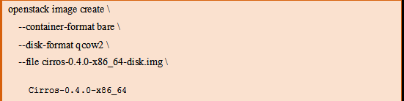

Confirm image upload.

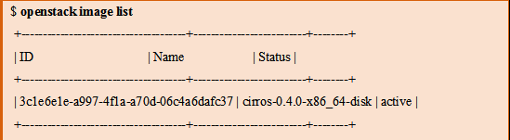

It should be visible from the Web UI

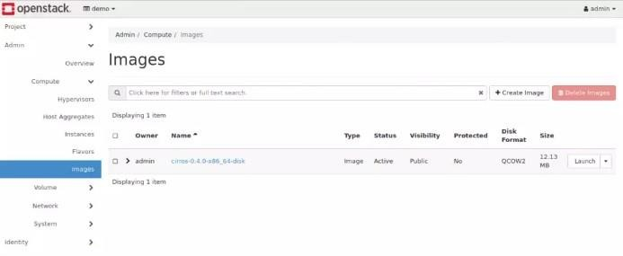

# Conclusion :

**OpenStack is a cloud working framework that controls huge pools of process, stockpiling, and systems administration assets all through a datacenter, all oversaw and provisioned through APIs with regular verification components.**

|  |  |  |  |  |  |
| --- | --- | --- | --- | --- | --- |
| **Program Execution/ formation/ correction/ ethical practices**  **(07)** | **Documentation (02)** | **Punctuality (01)** | **Viva Answer (05)** | **Experiment Marks (15)** | **Teacher Signature with date** |
|  |  |  |  |  |  |

# Output

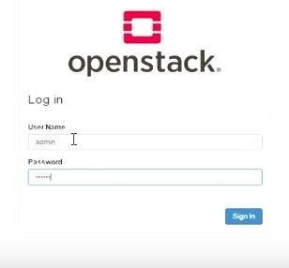

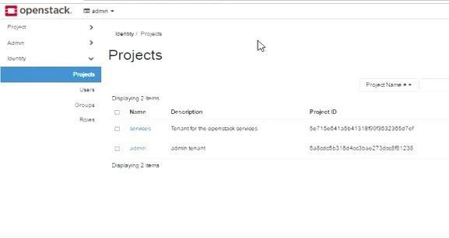

**Conclusion**

Here we have worked with Openstack. It is a free open standard distributed computing stage, generally conveyed as foundation as-an administration (IaaS) in both open and private mists where virtual servers and different assets are made accessible to clients.

**Module 04**

**Aim** : Software as a Service

**Objective:** Understand on demand application delivery and Virtual desktop infrastructure.

**Technology:** Ulteo

# Theory:

Ulteo Open Virtual Desktop (OVD) is a delivery platform that provides on-demand access to private and public cloud hosted virtual desktops and supports Windows Remote Desktop Services and Linux hosted desktop and application sessions. OVD enables organizations to integrate and seamlessly deliver them as a secure service to clients based on Windows, Linux, MacOS, Android and IOS platforms. The challenge for IT is to deliver solutions that satisfy the increasing newly technological demands within their existing budget. Ulteo helps organizations respond to these challenges by providing a scalable and powerful infrastructure that enables IT to transform the way it delivers and manages desktops and applications helping the business to reduce the complexity and overheads associated with traditional delivery methods.

### Key Benefits

* **Transform IT Delivery**:

Deliver hosted virtual desktops and applications on-demand.

### Reduce Complexity:

Simplify the process of desktop and application management and delivery.

### Lower Costs:

Reduced complexity leads to lower infrastructure costs. In addition Ulteo provides perpetual license free affordable software subscription plans.

### Platform Features

* **Open Architecture** - Open source, open architecture, cross platform with Windows and Linux support, open to integration and perpetual license free!
* **Simplicity** - Feature rich and flexible platform with an easy-to-use seamless user experience
* **Scalability** - The OVD architecture has been designed for performance and scalability

incorporating advanced server load balancing. Performance tuning and

comprehensive testing of Windows and Linux application servers ensures efficient load handling and directory management.

* **Hi-Def Delivery** - The UxDA display protocol has been developed to deliver a rich user experience that parallels that of a local PC and supports the use of local peripherals such as printers and storage while being Microsoft RDP compatible.

### Procedure:

OVD Virtual appliance works with both on VMware or VirtualBox. For easy setup, use a DHCP network with a bridged interface on your host machine configuration.

Following are the steps to use the Ulteo Open Virtual Desktop "Web Client", its capabilities and how to launch Ulteo OVD sessions using a web client:

Step 1: Open VMware.

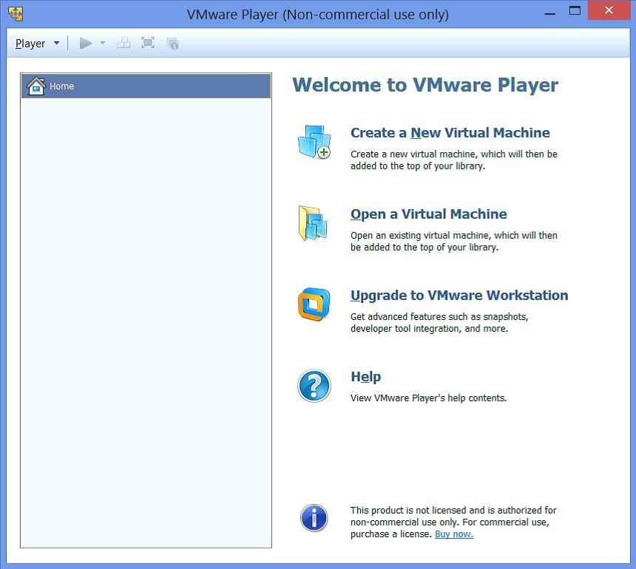

Step 2: Import OVA file into VMware.

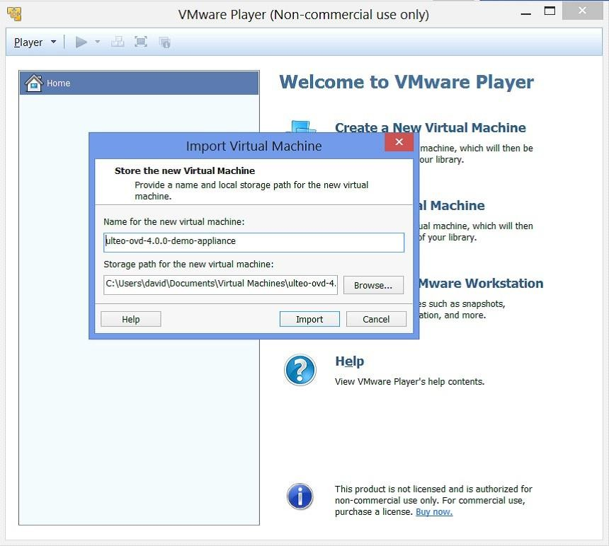

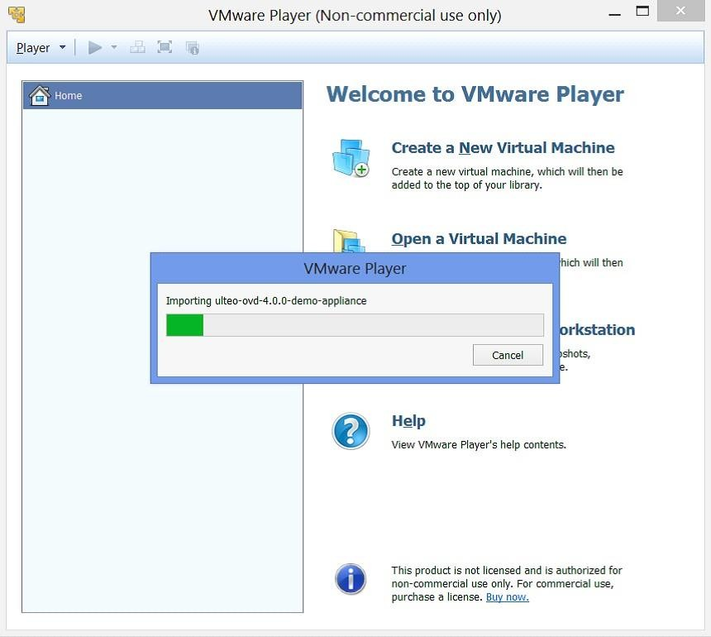

Step 3: Running the virtual appliance.

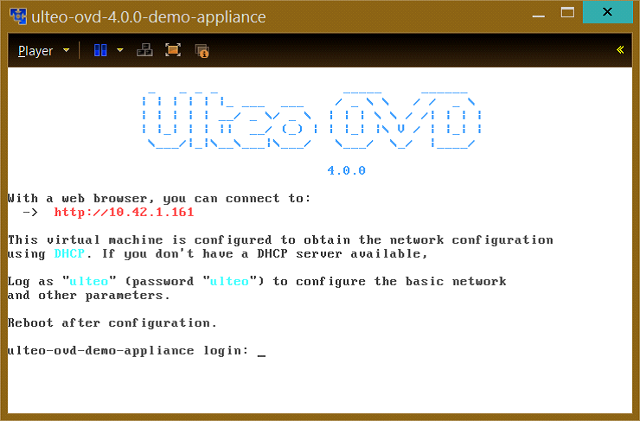

Step 4 : Open a we browser and access URL provided by ulteo-appliance. Here it is: [http://10.42.1.161](http://10.42.1.161/)

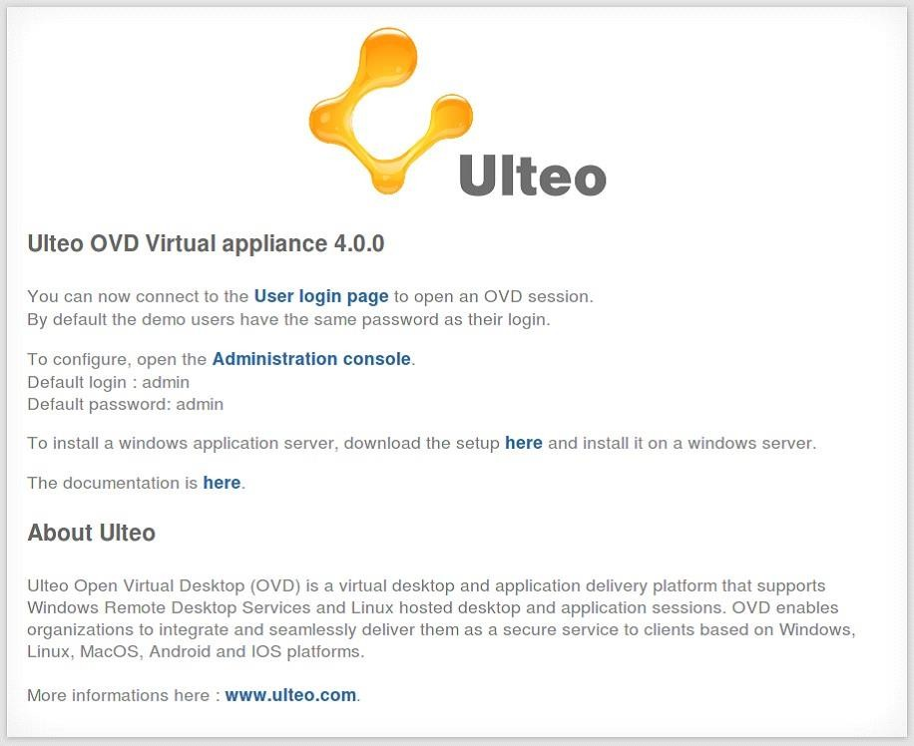

Step 5: Open the Administration Console, with username admin and password admin

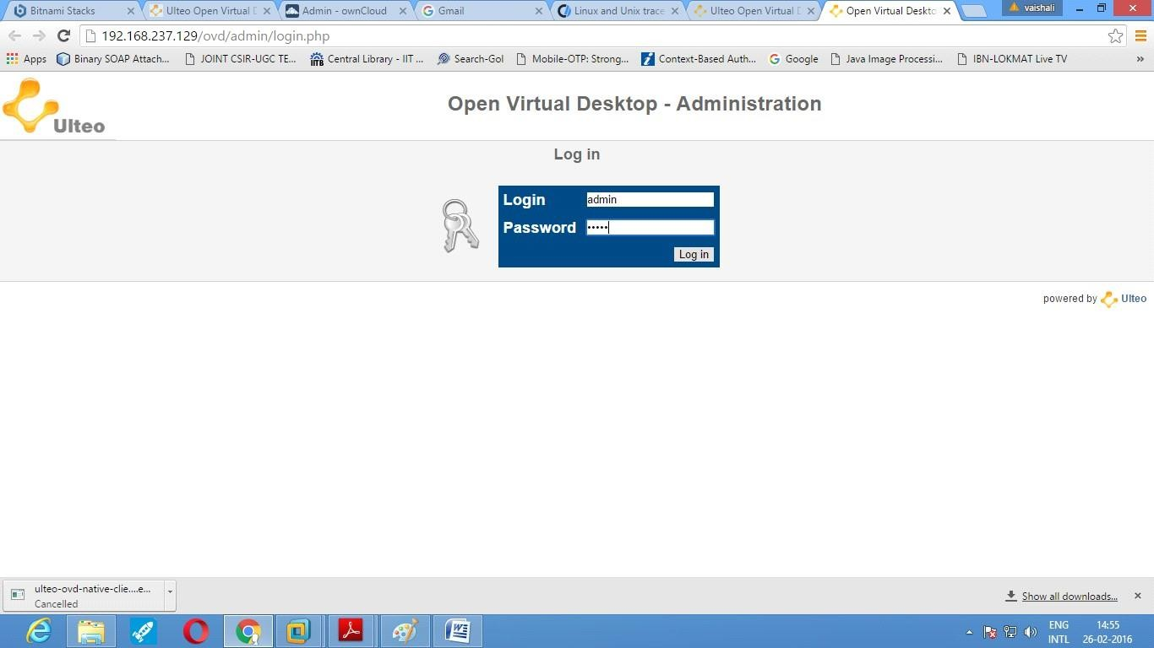

Step 6: Figure shows Home page of the Administration console. Edit the General configuration here.

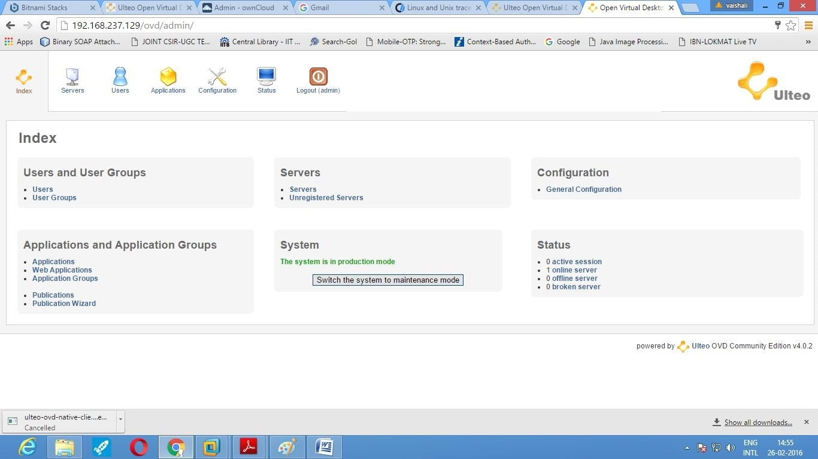

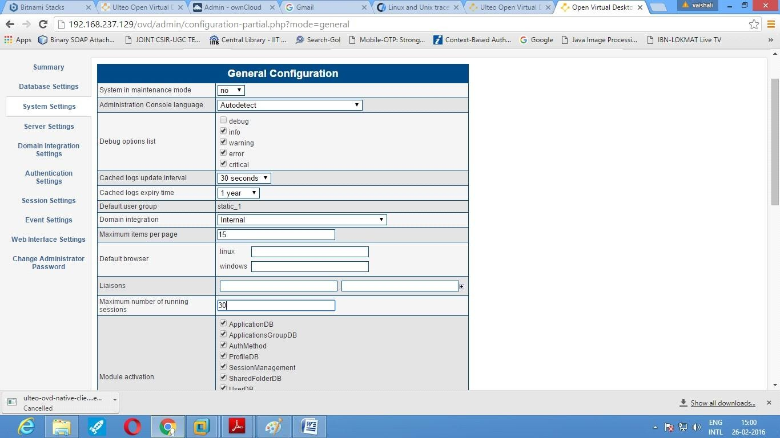

Step 7: To add user using Administration Console.

Note: Only 15 users are displayed by default. To view newly created user, we can delete few names from the existing list.

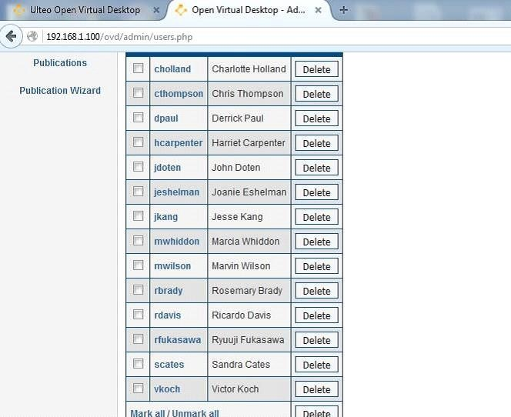

Step 8: Create User group.

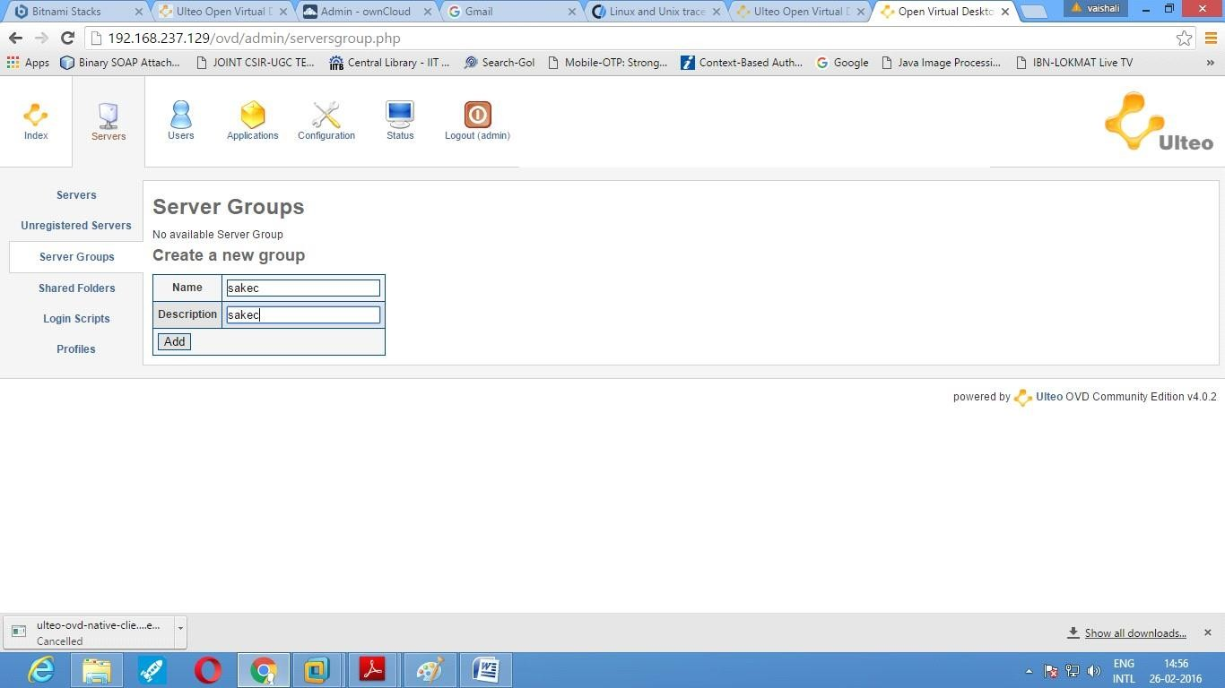

Step 9: Add users to the newly created groups.

Note: Use the "Add to this server" button to add the groups to the server.

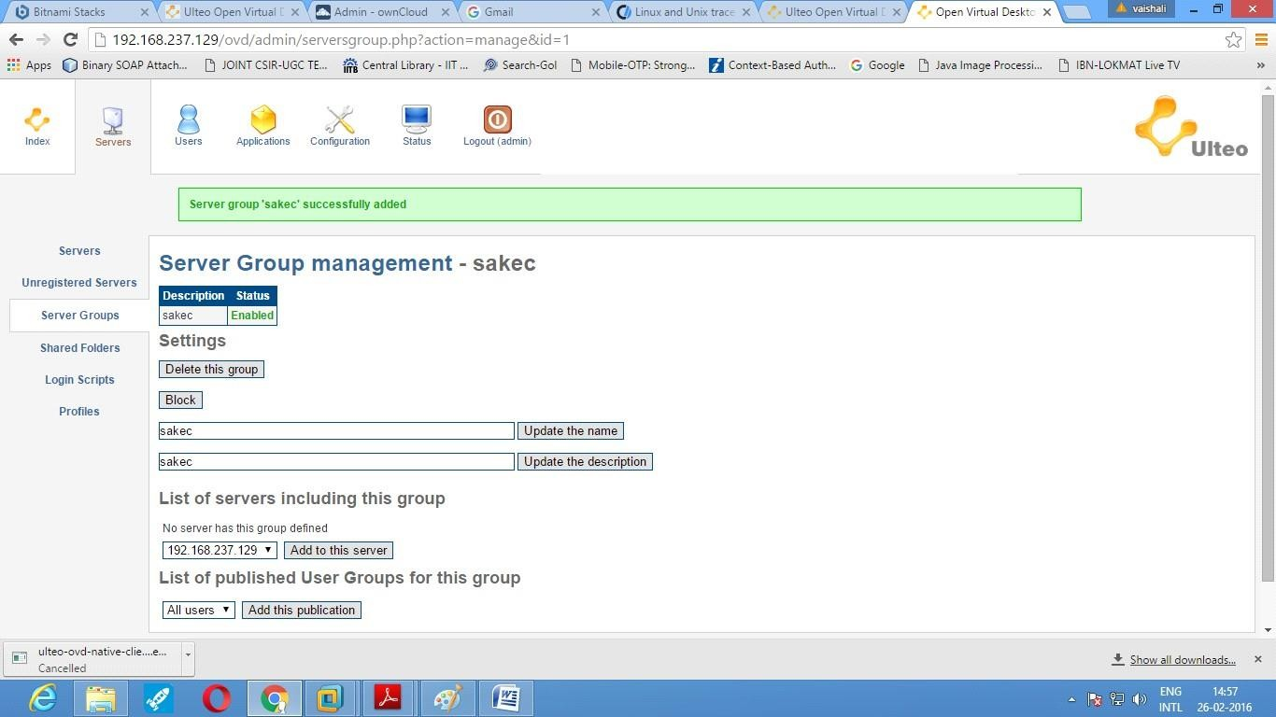

Step 10: Create Shared folder and assign the folder to the particular group.

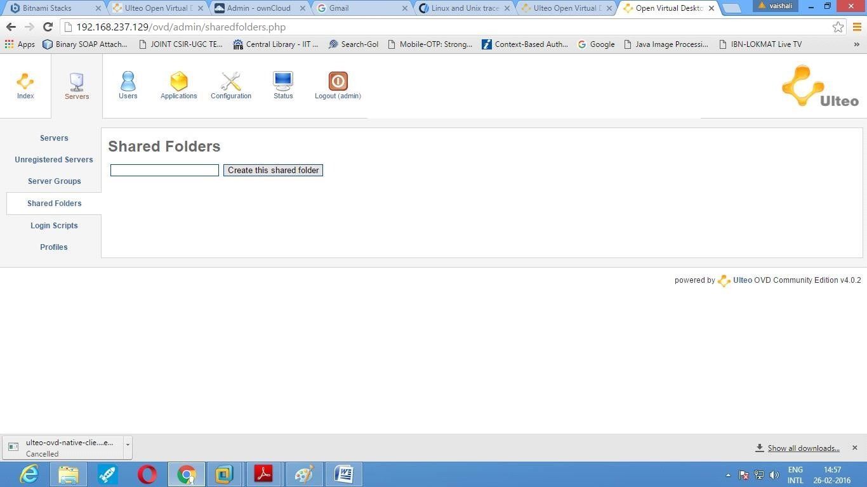

Note: You can view the shared folder by accessing User console from the home screen Step 11: To create a staic application, install the application package. For

example: vlc player.

1. Open Ulteo-ovd-appliance console and login as ulteo and password ulteo.

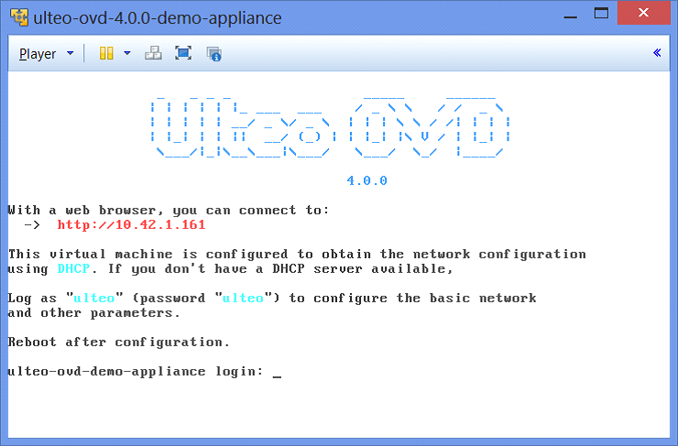

1. Select root console and install the package using sudo apt-get install vlc

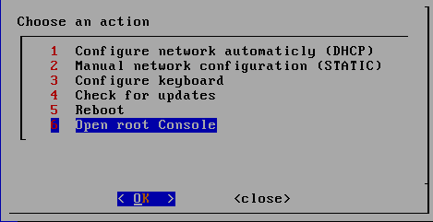

# sudo apt-get install vlc

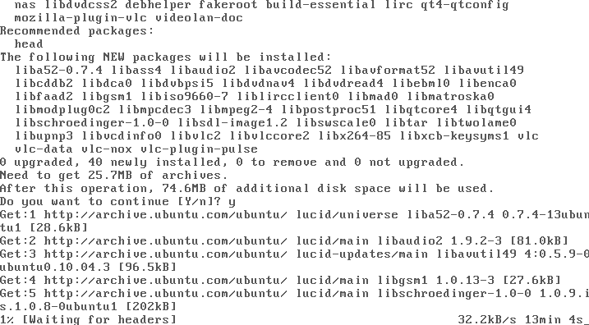

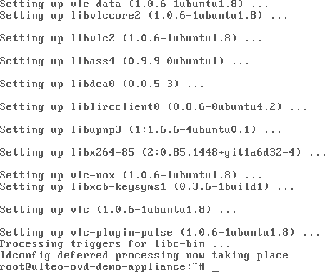

1. Go back to Administration console and add the static application (eg. vlc player) Note: The application can be provided to users by assigning it to the user groups.

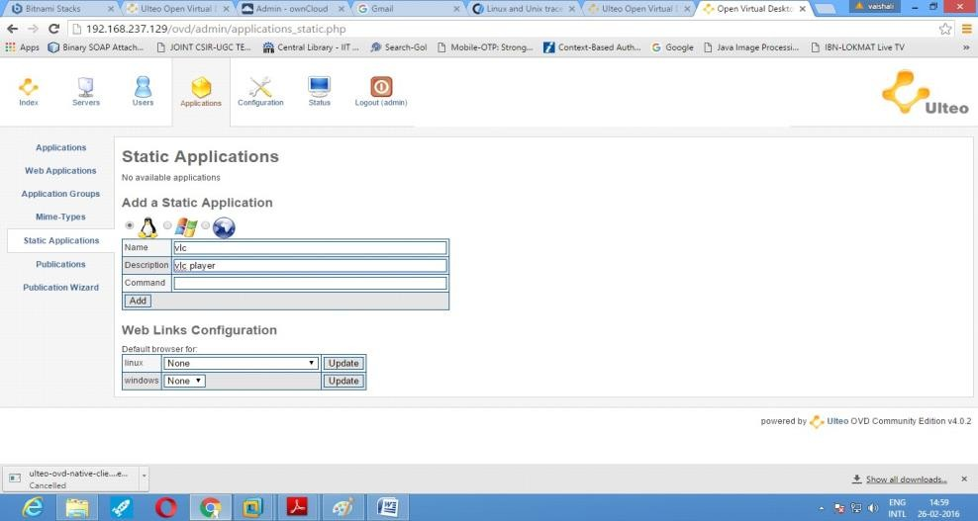

Step 12:

Login into the user console and access the Open Virtual Desktop provided by Ulteo. The application added at the server through the administrator console will be available to the users along with already exixting applications in the application group.

### CONCLUSION:

Ulteo Open Virtual Desktop (OVD) is a conveyance stage that gives on-request access to private and open cloud facilitated virtual work areas..

|  |  |  |  |  |  |
| --- | --- | --- | --- | --- | --- |
| **Program Execution/ formation/ correction/ ethical**  **practices (07)** | **Documentation (02)** | **Punctuality (01)** | **Viva Answer (05)** | **Experiment Marks (15)** | **Teacher Signature with date** |
|  |  |  |  |  |  |

# Output:

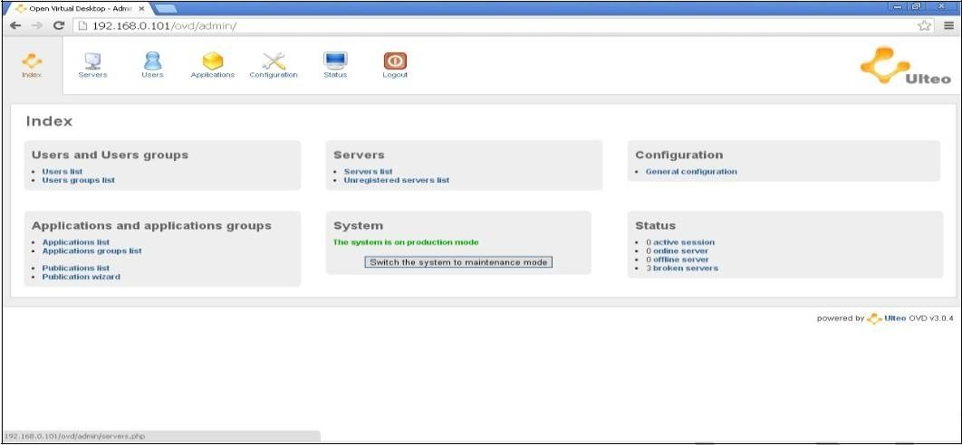

### Ulteo Application Menu

**Ulteo Administrator panel**

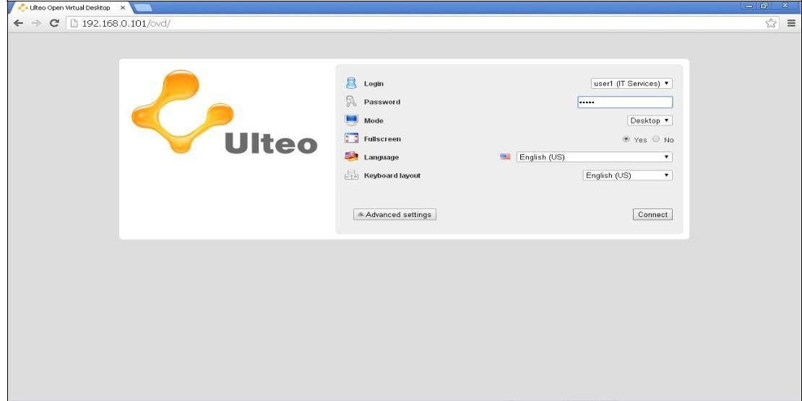

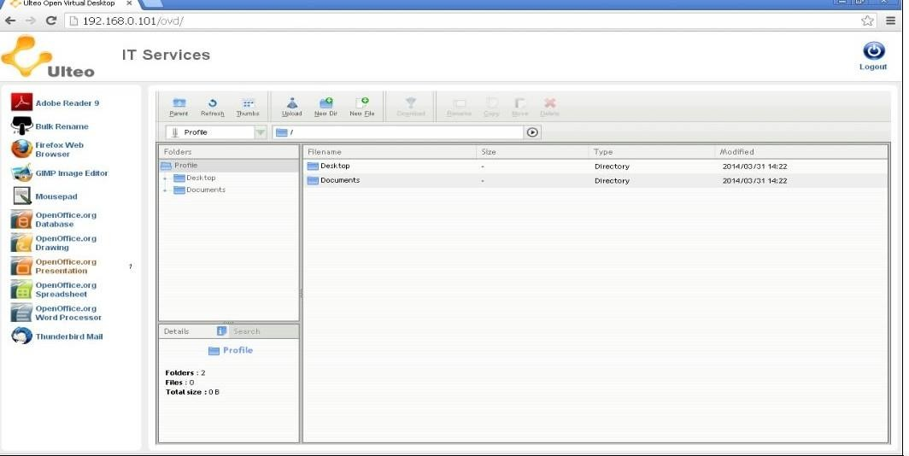**Ulteo user Login Portal**

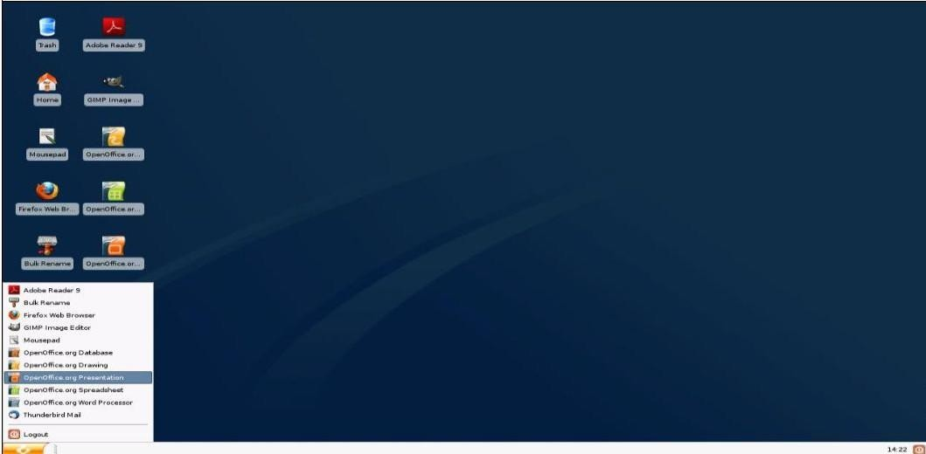**Ulteo Portal mode**

**Conclusion**

In this investigation we have found out about UIteo. It is an open virtual work area. It permits us to give clients remote access to work areas and applications.

**Module 05**

**Aim** : Implement Storage as a service and cloud security using Owncloud.

**Objective:** To learn concept of SaaS and implement using OwnCloud which gives universal access to files through a web interface.

**Technology:** ownCloud

# Theory:

The Bitnami ownCloud Stack provides a one-click install solution for ownCloud. Download installers and virtual machines, or run your own ownCloud server in the cloud.

ownCloud is a personal productivity powerhouse. It gives you universal access to all your files, contacts, calendars and bookmarks across all of your devices. Unlike many of the shared repository services out there, with ownCloud, you have your own, private repo. However, just like the public repo companies, with ownCloud you can share your files with friends and co-workers. If you need it, ownCloud even integrates with other storage providers. Best of all, ownCloud is open source and free!

Bitnami makes it easy to run ownCloud in the cloud, locally or virtually. Features of Bitnami ownCloud Stack are:

* 1. Up-to-date: Every release of ownCloud is tracked and updated stack is released.
  2. Secure: If serious security issues are discovered, new versions of ownCloud are provided as soon as possible, often within hours of the availability of a fix.
  3. Consistent: With Bitnami, you get the same software stack and configuration regardless of where you are deploying ownCloud or other Bitnami Applications. This makes it easy to migrate between different platforms.
  4. With the Bitnami ownCloud Stack stack compiling, configuring and all of its dependencies are taken care of, so it works out-of-the-box.

# Procedure:

Step1: Download ownCloud Virtual Machines from https://bitnami.com/stack/owncloud/installer#lin ux

bitnami-owncloud-8.2.1-0-ubuntu-

14.04 Step 2:

Open Oracle VM. File-> Open appliances and select bitnami-owncloud-10.3.2-0- linux- debian-9-x86_64.ova file

Bitnami virtual machine images contain a minimal Linux operating system and a fully configured Bitnami application stack. Running virtual machine images requires a hypervisor such as VMware or VirtualBox, so it is recommended for system administrators and advanced users.

Step 3: username – bitnami Password- bitnami

Step 4: Try accessing the application using the IP address provided by the bitnami ownCloud stack through browser.

The default login information for ownCloud cloud images is: Username: user

Password:

bitnami

Step 4: User can be created using the following steps:

1. Click on User -> Users -> provide username and password.
2. Assign the group name.
3. Click on Create.

Step 5: User group can be created using the following steps:

1. Click on Add Group and provide the group name.
2. Click on ‘+’ sign.

Step 6: Administrative features can be set using the following steps:

1. Click on User-> Admin.
2. Here we can configure different features like: Sharing, Server-side Encryption, File

Handling, Mail Templates, Cron, Email server, Log.

# Conclusion:

ownCloud gives widespread access to every one of your documents, contacts, schedules and bookmarks over the entirety of your gadgets. Not at all like a considerable lot of the common vault benefits out there, with ownCloud, you have your own, private repo.

|  |  |  |  |  |  |
| --- | --- | --- | --- | --- | --- |
| **Program Execution/ formation/ correction/ ethical practices**  **(07)** | **Documentation (02)** | **Punctuality (01)** | **Viva Answer (05)** | **Experiment Marks (15)** | **Teacher Signature with date** |
|  |  |  |  |  |  |

# Output

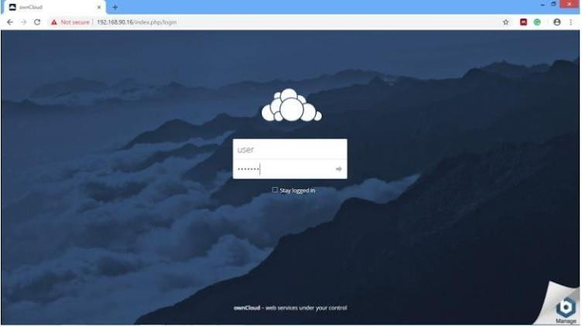

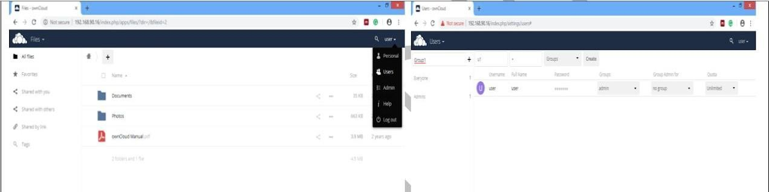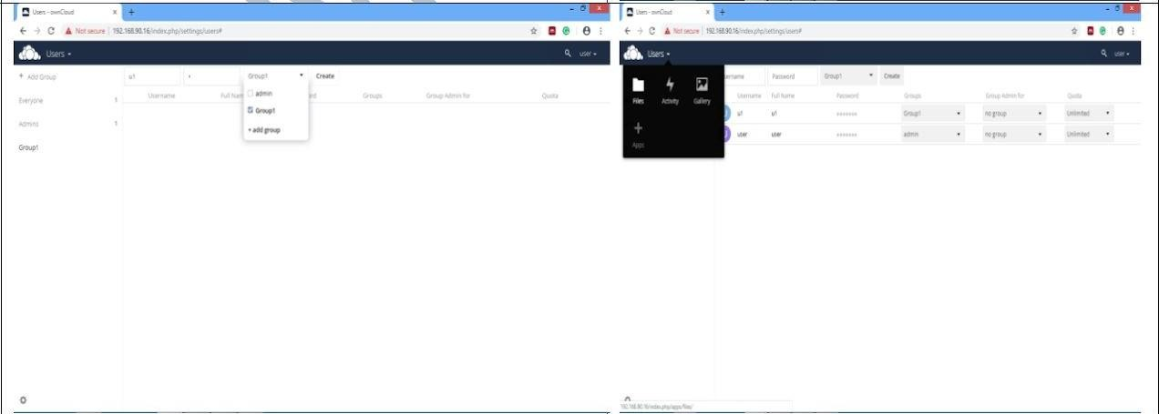

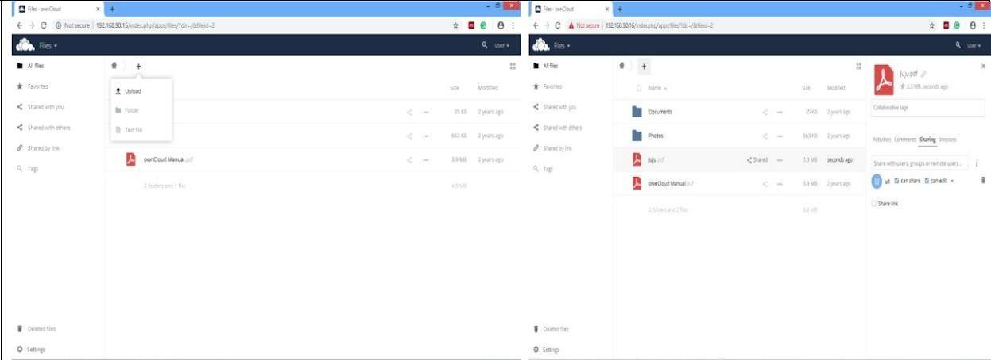

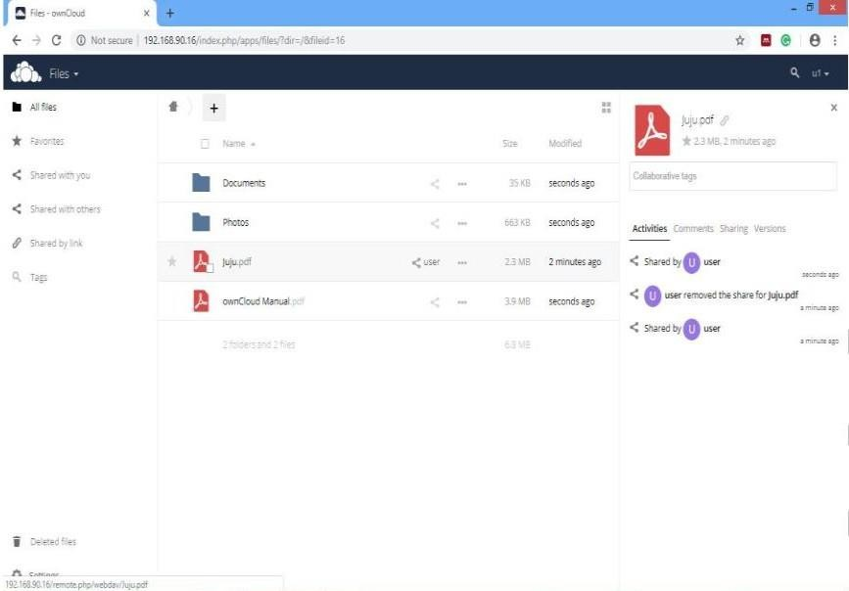

**Conclusion**

We have this actualized Storage as a help and cloud security utilizing Owncloud. Capacity as a Service. Capacity as a help (SaaS) is a cloud plan of action in which an organization rents or leases its stockpiling foundation to another organization or people to store data..The stockpiling supplier gives the customer the product required to get to their put away information. OwnCloud is a set-up of customer server programming for making and utilizing document facilitating administrations.

### Module 07

**Title:** Amazon Web Service

**Objective:** To demonstrate and implement IAAS service using AWS (Use t2.Micro (Free tier eligible) (instance only).

### Technology: AWS

**Theory:**

Step 1 -: Login to AWS portal and Select EC2 service from admin console

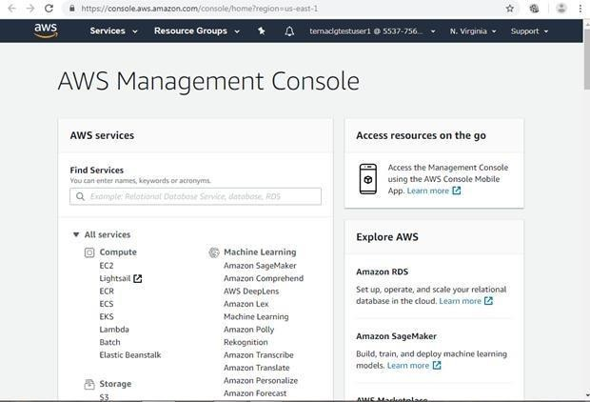

Step 2-: The EC2 resource page will appear which will show you the summary of instances. Now click on launch instance to select the VM instance type

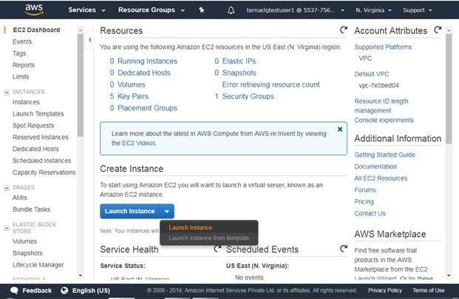

Step 3-: Select the operating system type in AMI format. In this example we have selected Windows server instance which is eligible for free tier and click on Next.

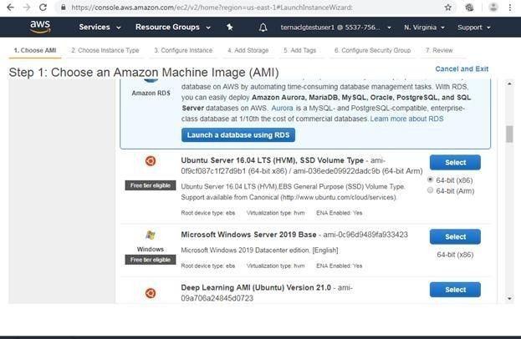

Step 4 -: Now select the hardware type for Virtual machine. In this example we have selected free tier eligible General purpose hardware and click on Next.

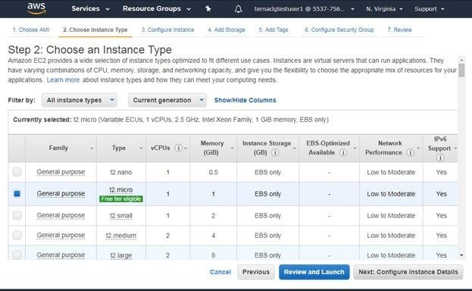

Step 5-: Now specify the instance details like Number of instances, networking options like VPC, Subnet ot dhcp public IP etc. and click on Next

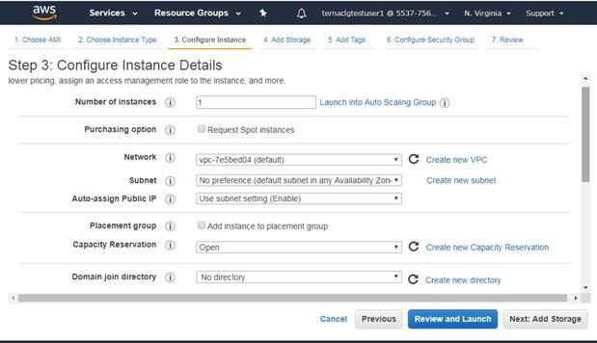

Step 6-: Specify the storage space for VM and click on Next

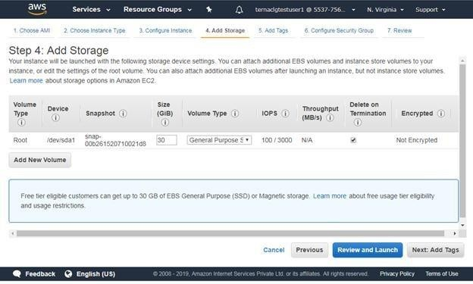

Step 6-: Click on Add tag to specify VM Name and click on Next

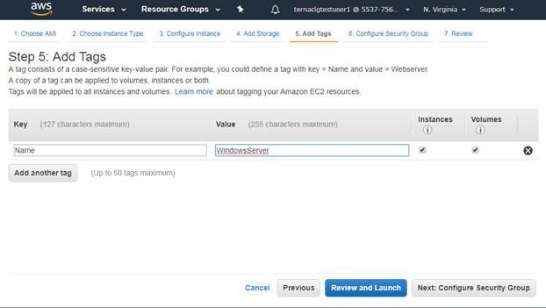

Step 6-: Configure security group to provide access to VM using different protocols.In this example we have selected default RDP protocol.

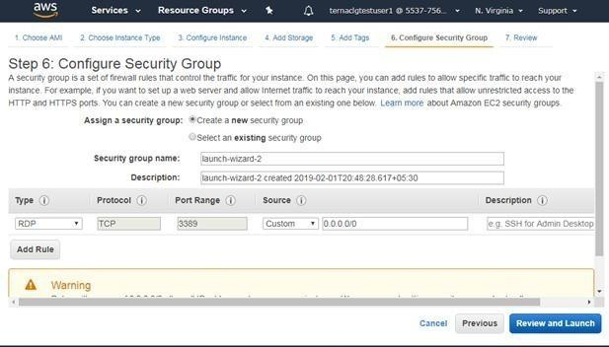

Step 7-: Now Review the instance and click on Launch button

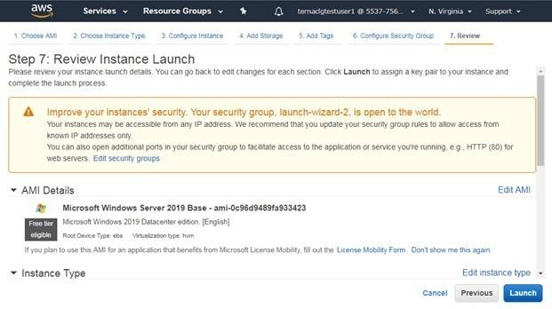

Step 8-: Now to secure VM instance, Encrypt it using public key and create a private key pair to decrypt that. Here specify key pair name and download key pair.

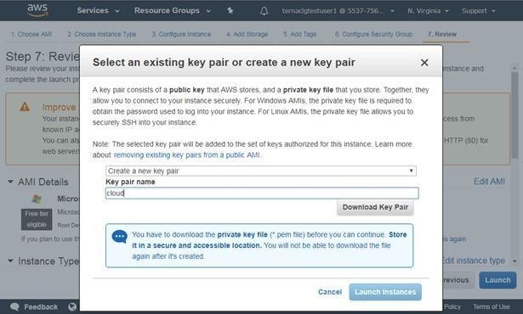

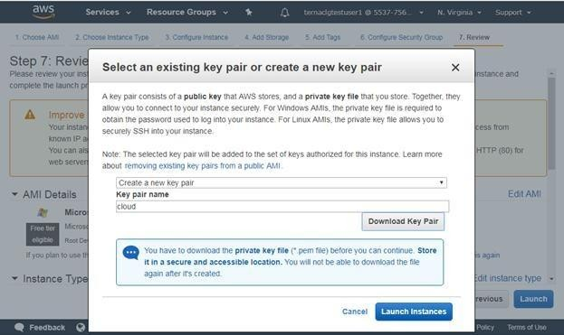Step 8-: Finally Click on launch instance to Launch VM

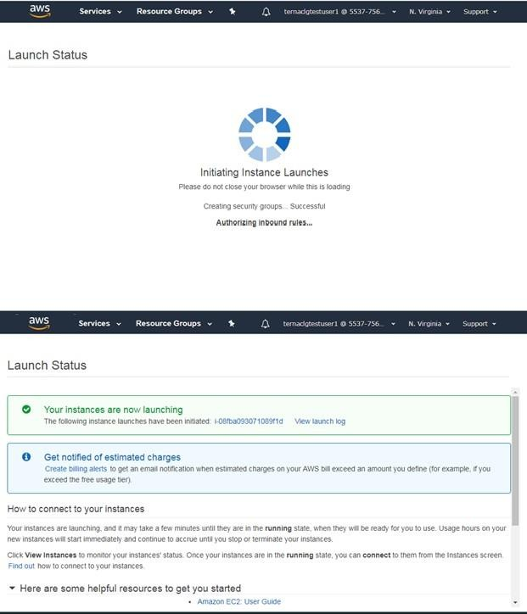

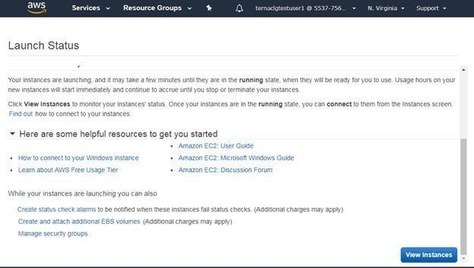

Step 9-: Now from summary page click on View instance to see the instance state. Afte some time you will see the running instance of your VM.

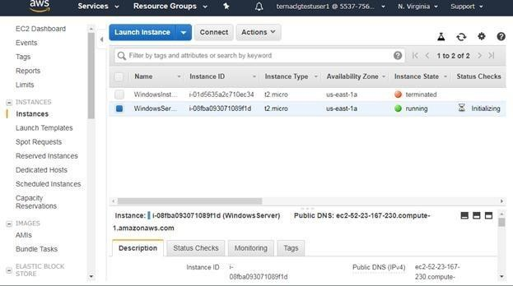

Step 10-:Now Click on Connect to get the password for VM to access it over RDP protocol.

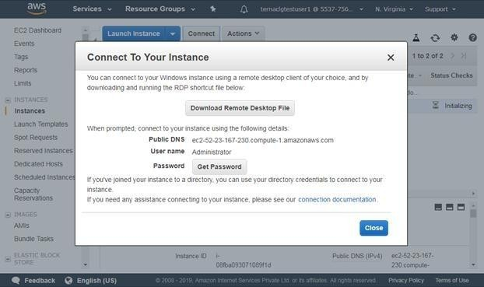

Step 11 -: Select the downloaded key pair file to decrypt the password.

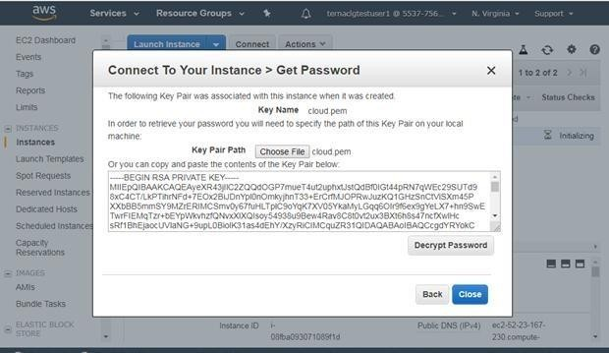

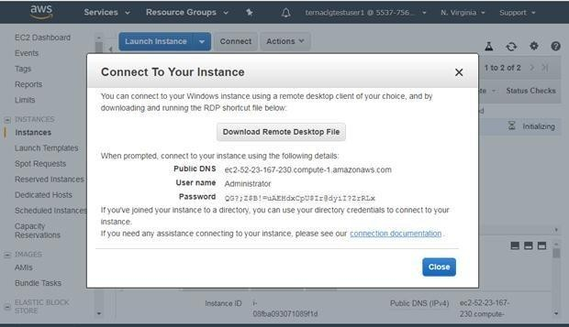

Step 12 -: Now connect the instance using RDP tool by using Ipaddress/DNS, username and Password decrypted in last step.

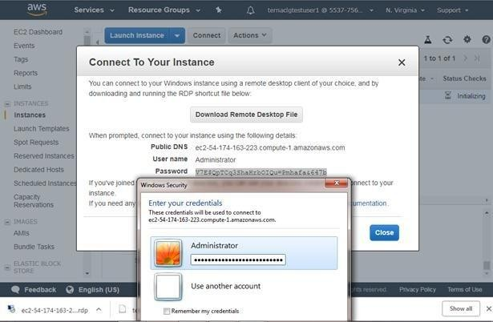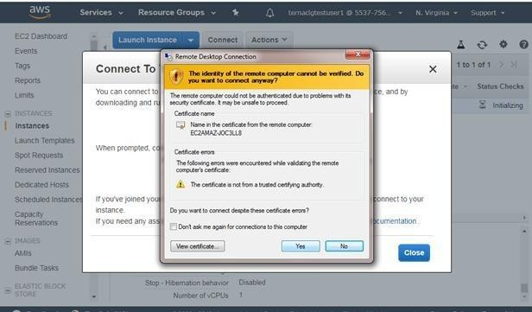

Step 13-: Once you click on connect, you will see the running Windows virtual machine as

shown

below.

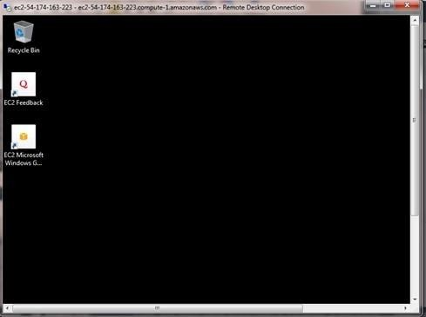

Step 14-: You can shut down instance by selecting instance state followed by stop

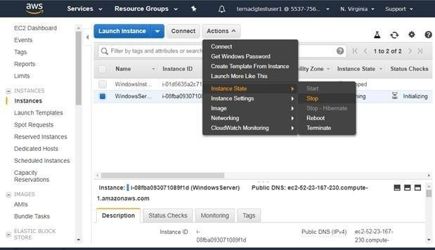

Step 15-: You can delete the instance permanently by selecting instance state followed by stop

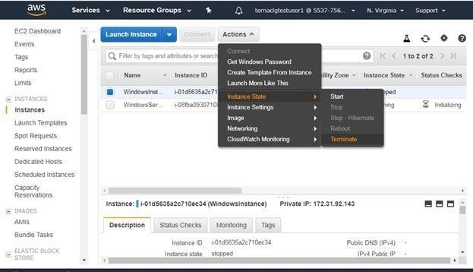

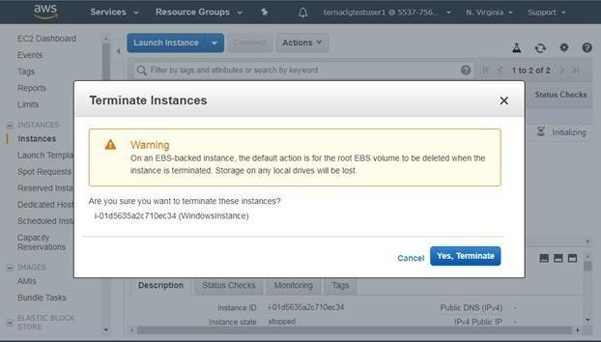

1. To create simple word press app using Light sail service in AWS (SAAS) Step 1-: Open Admin console of AWS and select light sail service

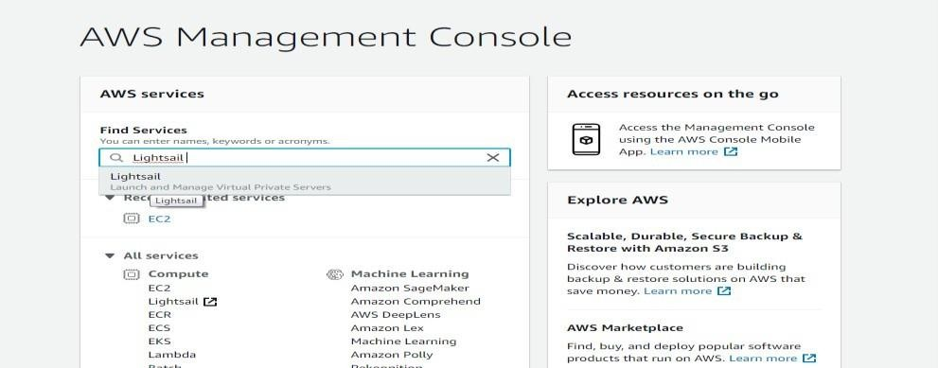

Step 2-: Select Create instance option

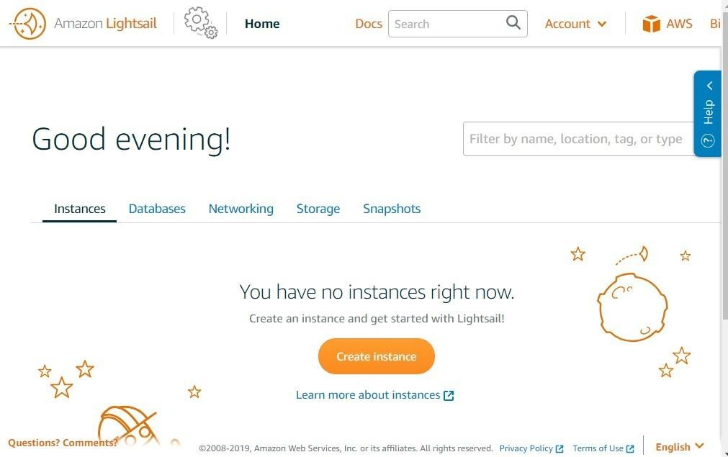

Step 3 -: Select the Linux hosting instance

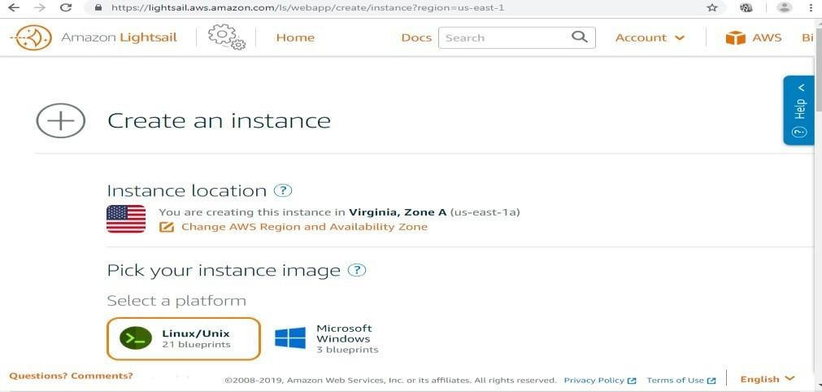

Step 4 -: Select word press hosing

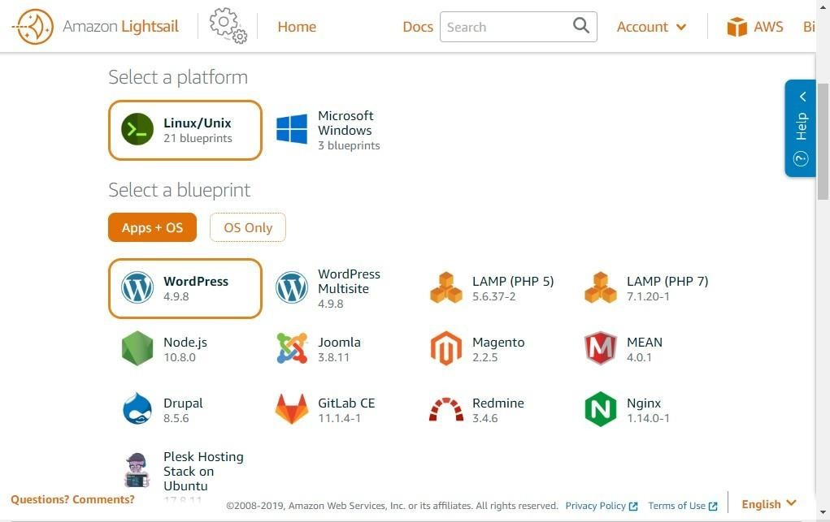

Step 5 -: Specify name to the instance

Step 6-: Now click on create to launch the instance Step

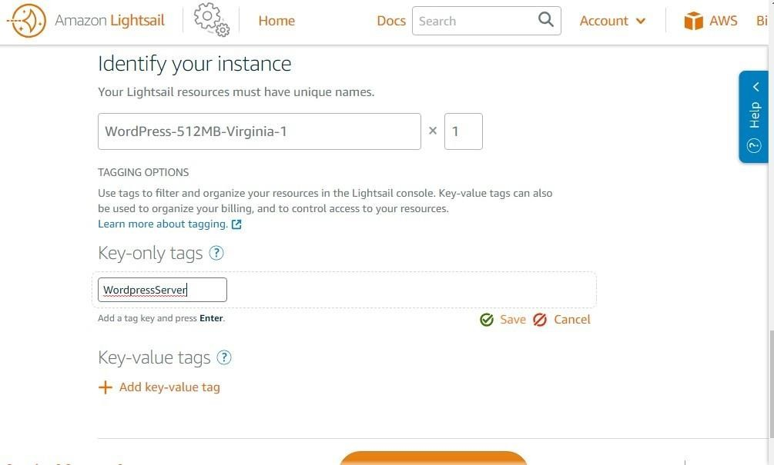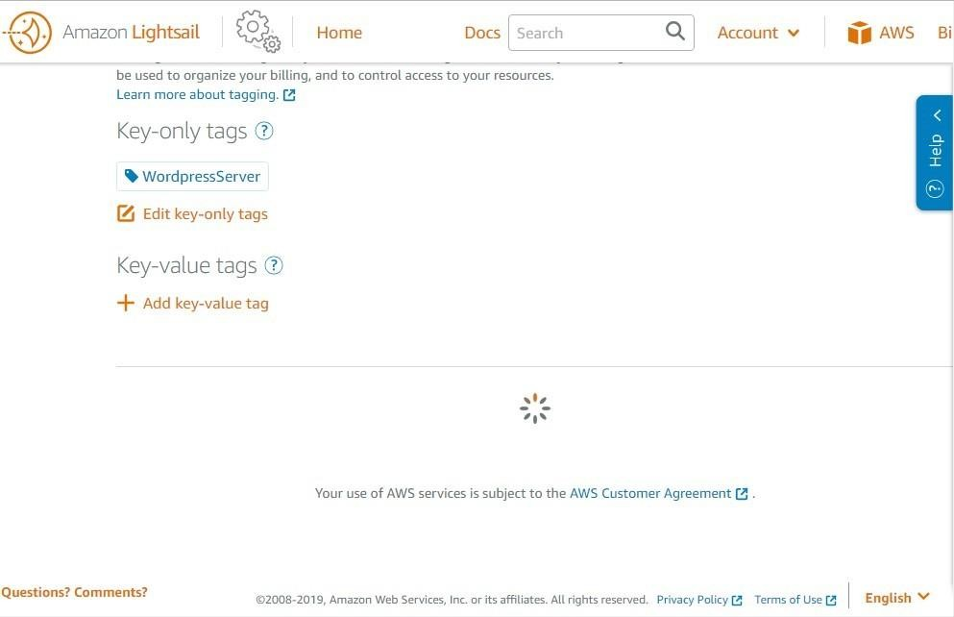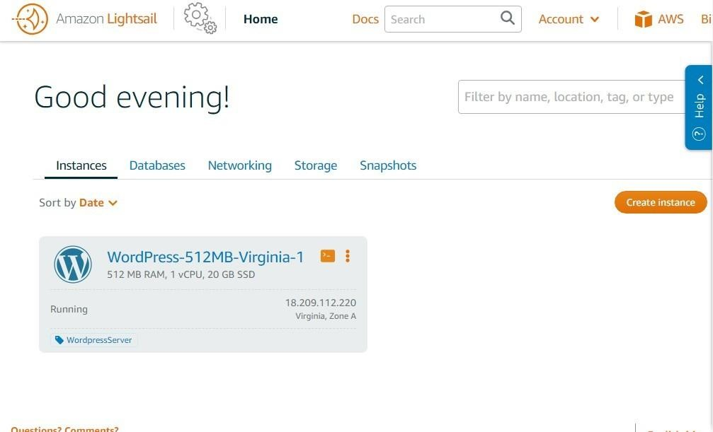

Step 7 -: Click on connect instance to get the password for

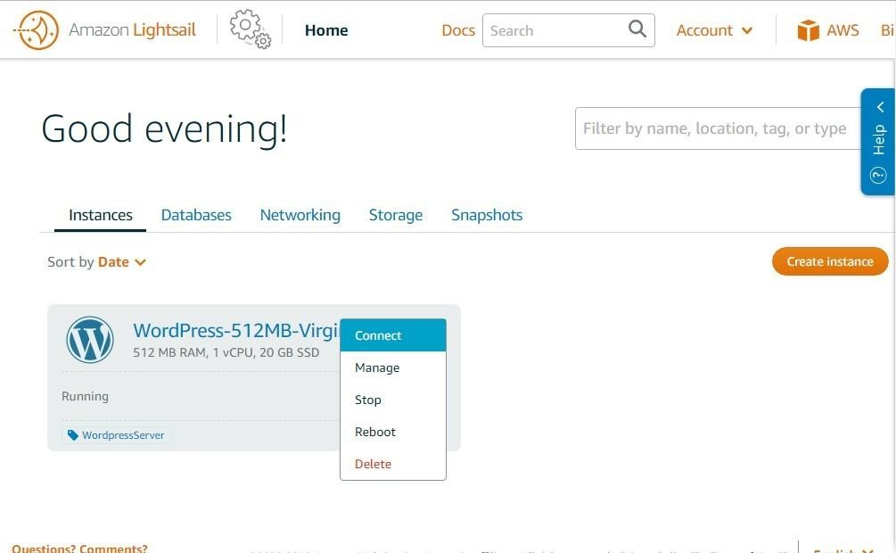

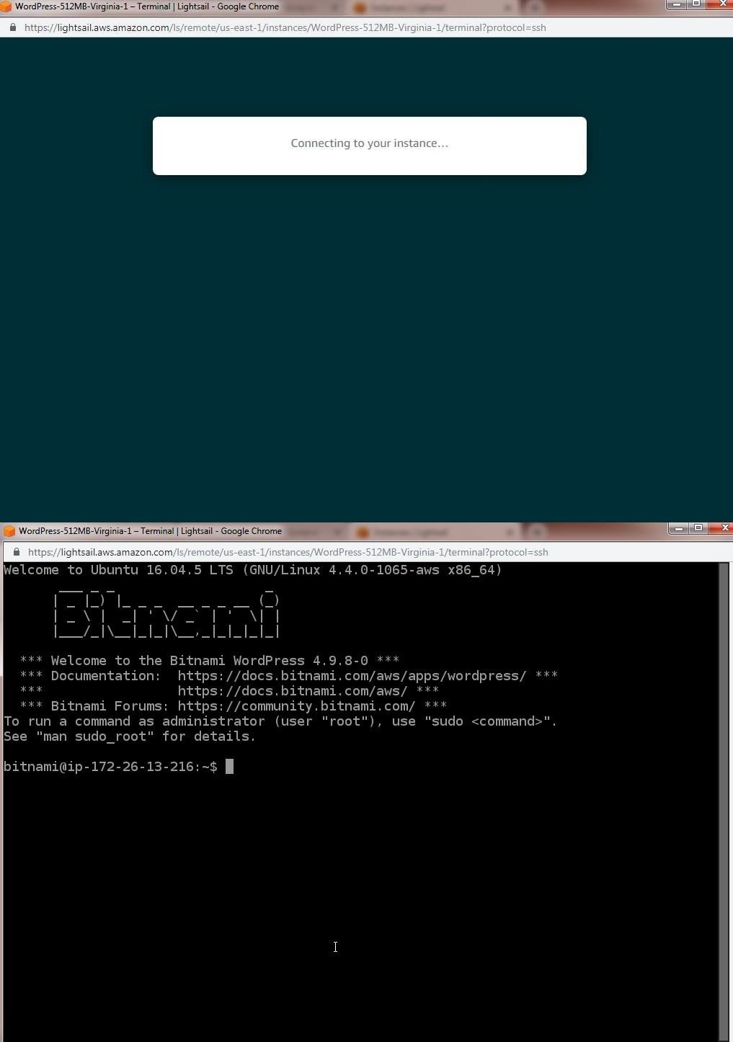

Step 8-: Now open bitnami_application_password file to get the admin password. So copy it and use over admin console

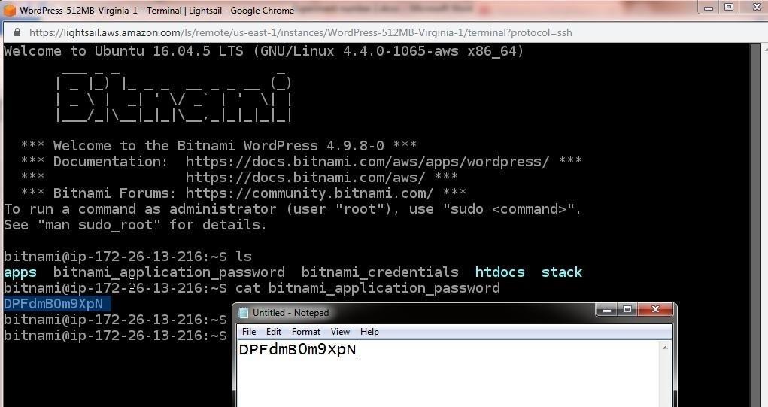

Step 9 -: Now researve static ip by selecting network option and creating static IP

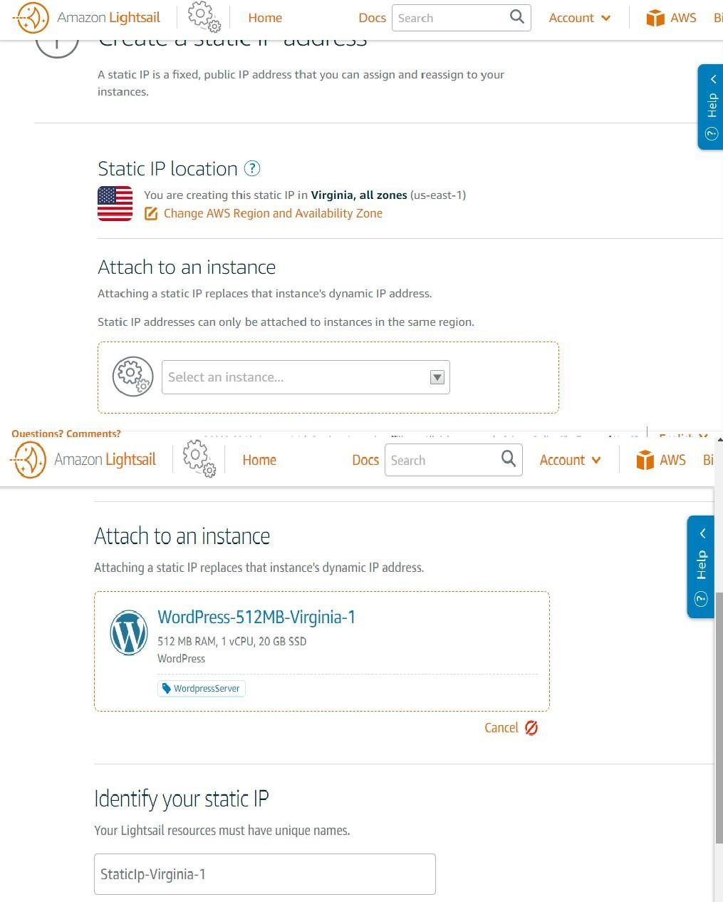

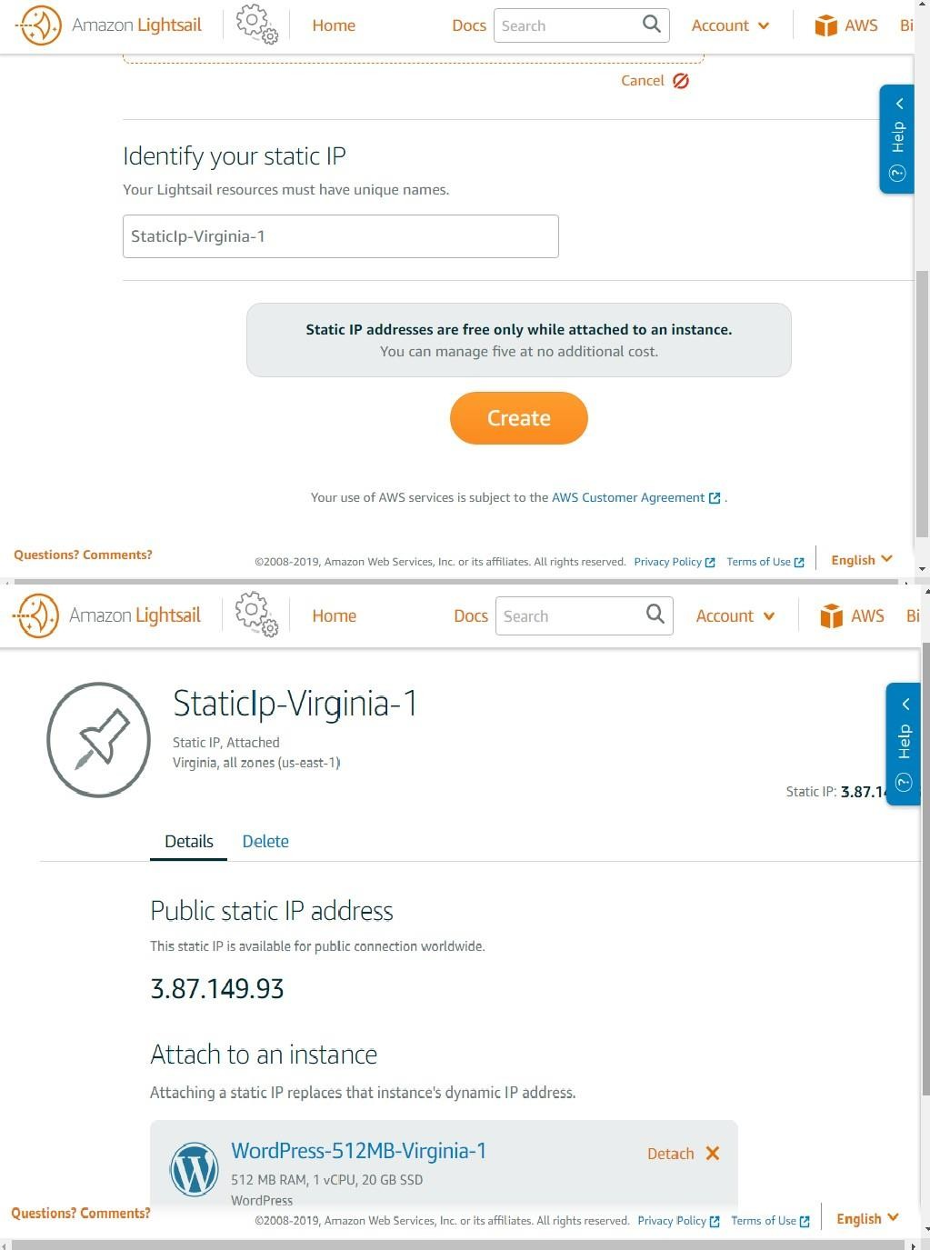

Once static IP is allocated then open that ip on browser to see Word press Website

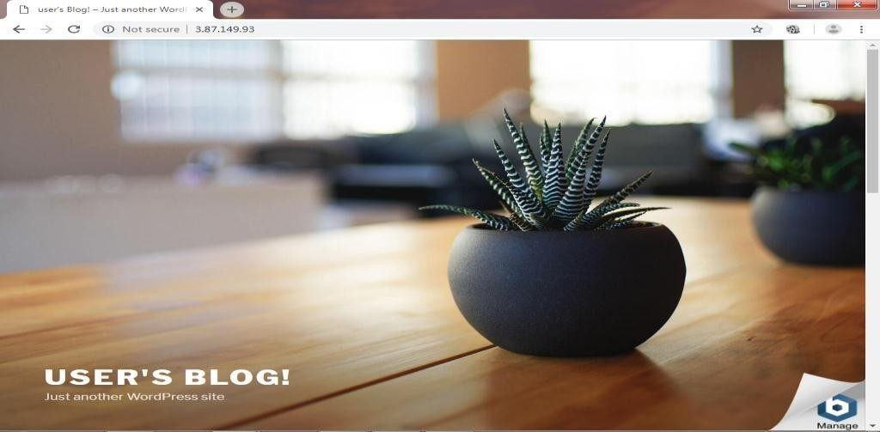

Open admin console of Word press and use password obtained in step 8 to open word press site builder. Now you can develop a complete Word press website and use that.

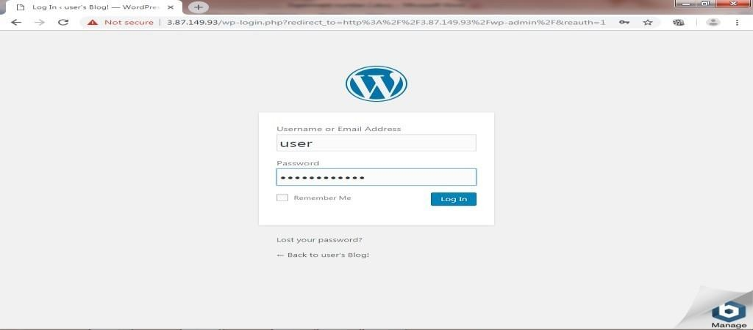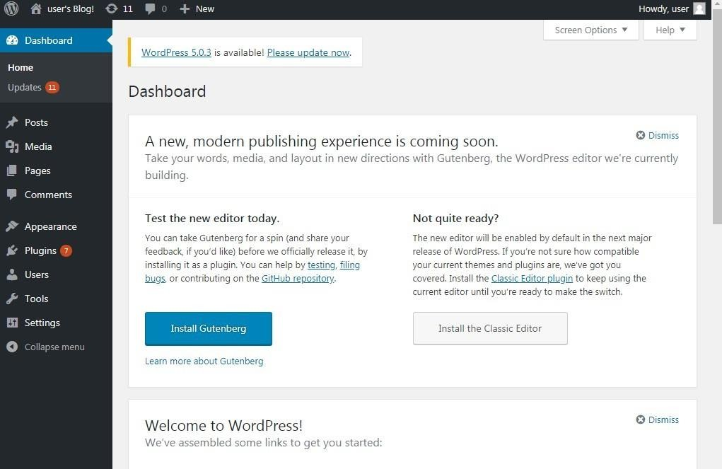

CONCLUSION:

Amazon Web Services (AWS) is a subsidiary of Amazon that provides on-demand cloud computing platforms and APIs to individuals, companies, and governments, on a metered pay-as- you-go basis. Subscribers can pay for a single virtual AWS computer, a dedicated physical computer, or clusters of either.

|  |  |  |  |  |  |
| --- | --- | --- | --- | --- | --- |
| **Program Execution/ formation/ correction/ ethical practices**  **(07)** | **Documentation (02)** | **Punctuality (01)** | **Viva Answer (05)** | **Experiment Marks (15)** | **Teacher Signature with date** |
|  |  |  |  |  |  |

# Output

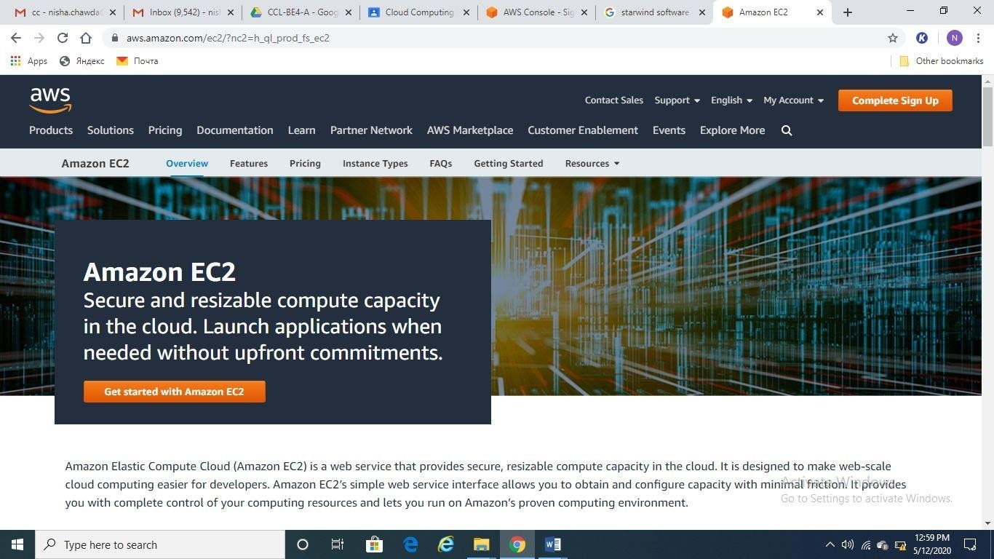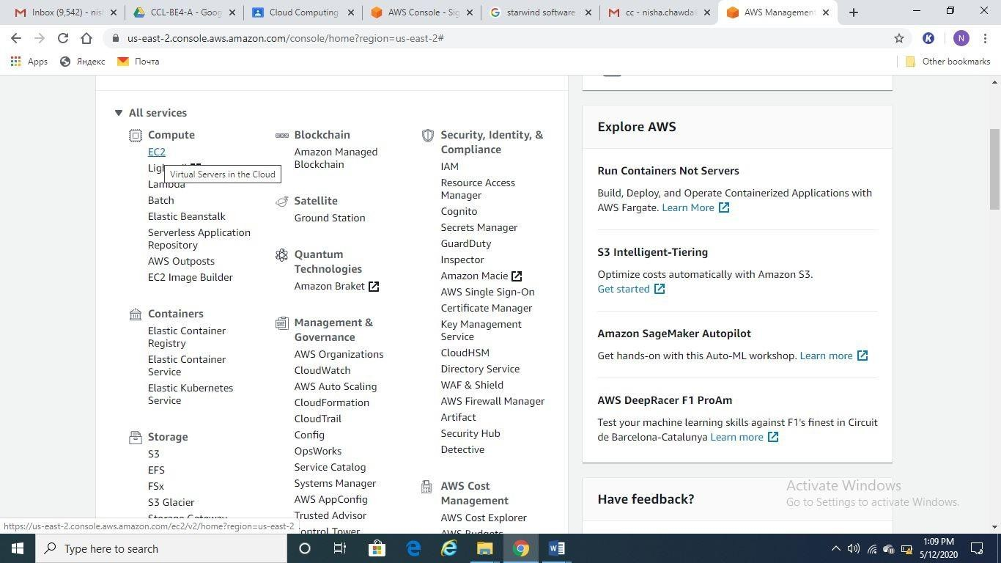

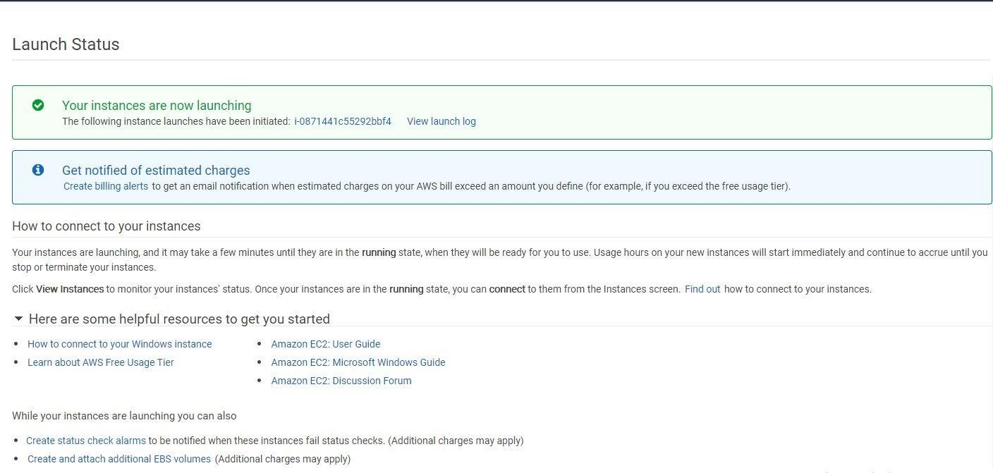

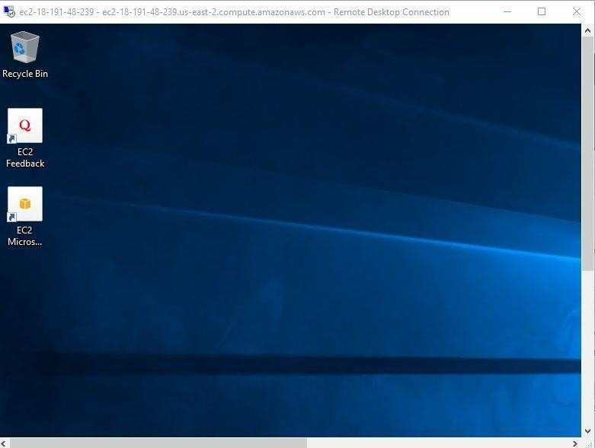

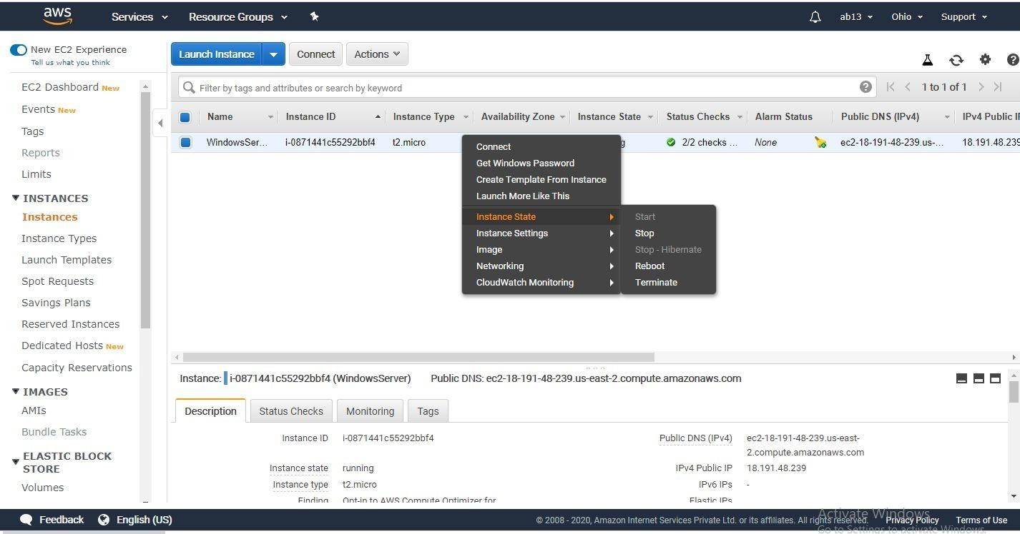

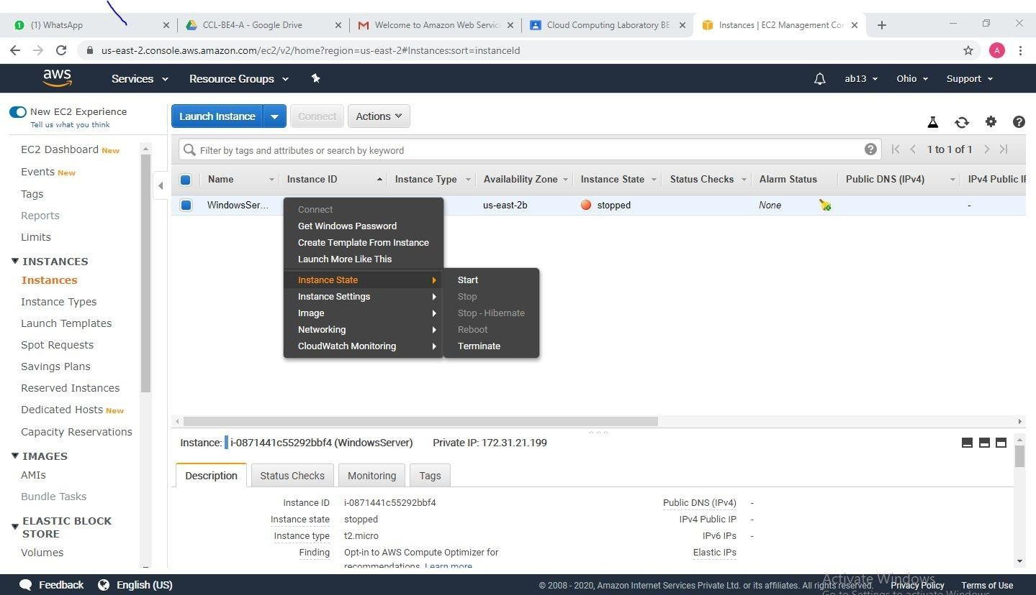

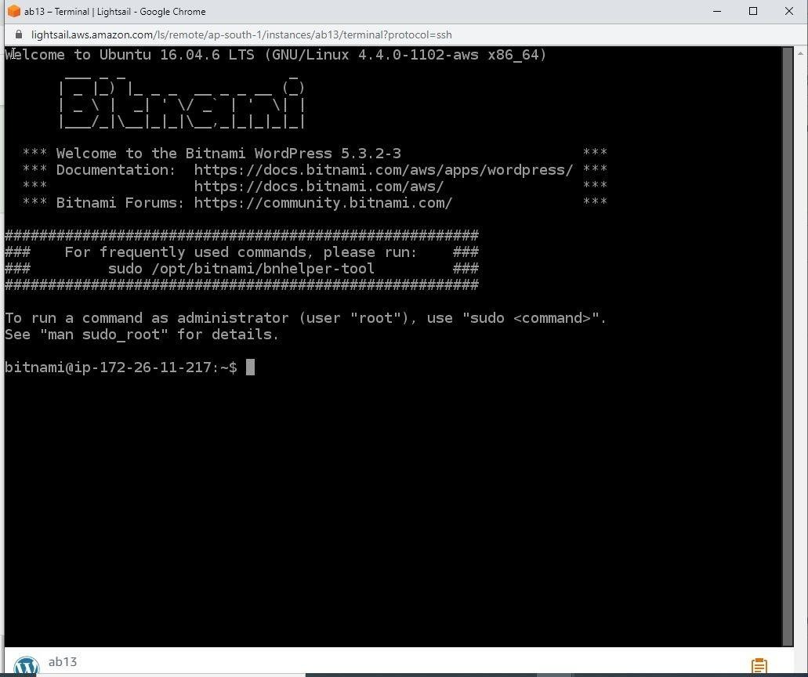

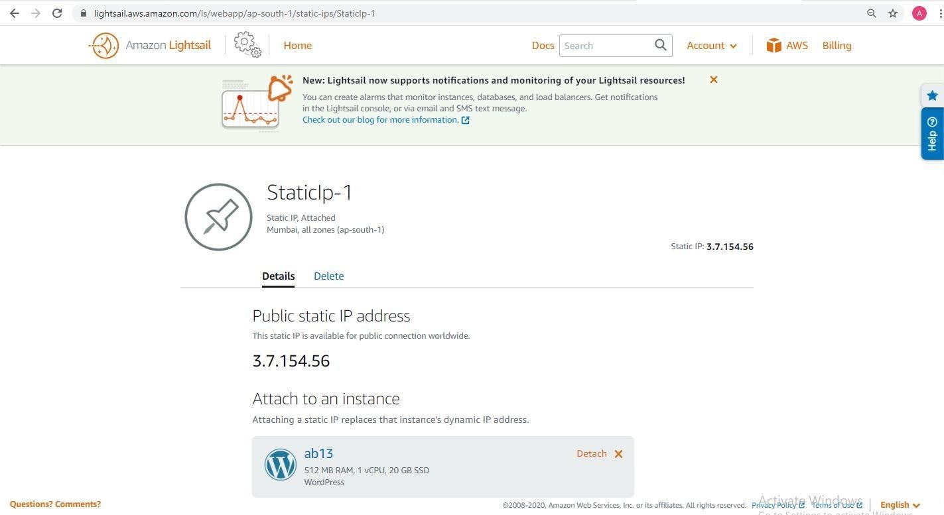

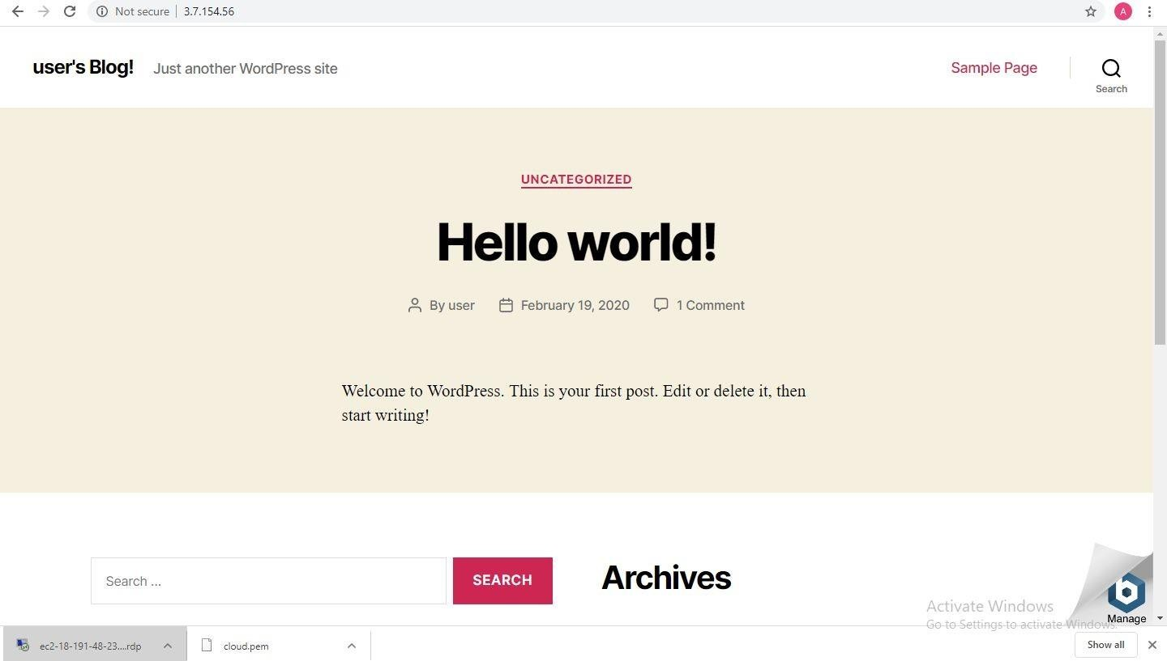

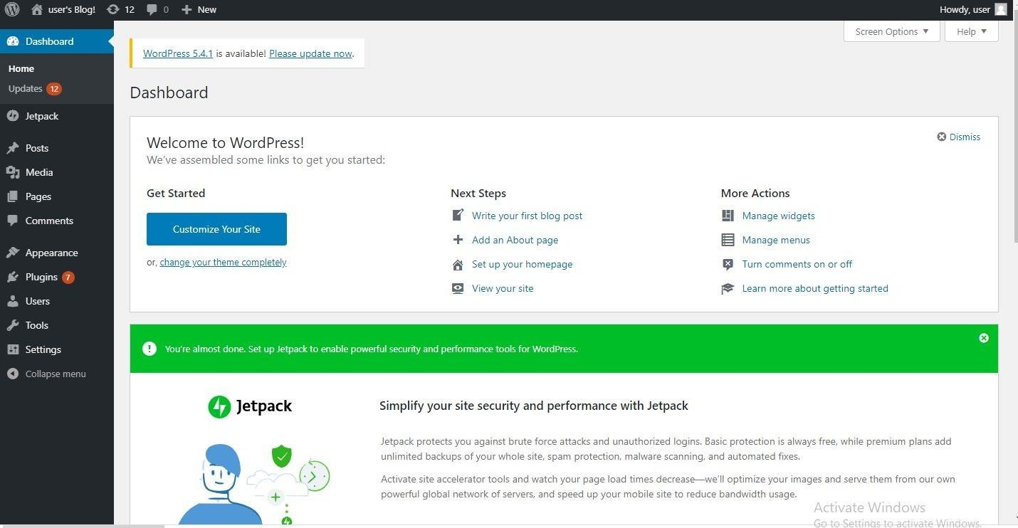

**Conclusion**

In this we have hence actualized IAAS administration utilizing AWS (Use t2.Micro (Free level qualified) (case as it were). We have made an example utilizing EC2.Amazon Web Services is an auxiliary of Amazon that gives on-request distributed computing stages and APIs to people, organizations, and governments, on a metered pay-more only as costs arise premise.

**Module 08**

**Aim**: Creating a virtual Storage Area Network (SAN) using Starwind.

### Theory:

The Storage Networking Industry Association (SNIA) defines the *storage area network* (*SAN*) as a network whose primary purpose is the transfer of data between computer systems and storage elements. A SAN consists of a communication infrastructure, which provides physical connections. It also includes a management layer, which organizes the connections, storage elements, and computer systems

so that data transfer is secure and robust. a SAN is a specialized, high-speed network that attaches servers and storage devices. The SAN is sometimes referred to as the *network behind the servers*. A SAN allows an *any- to-any* connection across the network, by using interconnect elements, such as switches and directors. The SAN eliminates the traditional dedicated connection between a server and storage, and the concept that the server effectively *owns and manages* the storage devices. a SAN introduces the flexibility of networking to enable one server or many heterogeneous servers to share a common storage utility. A network might include many storage devices, including disk, tape, and optical storage. Additionally, the storage utility might be located far from the servers that it uses.

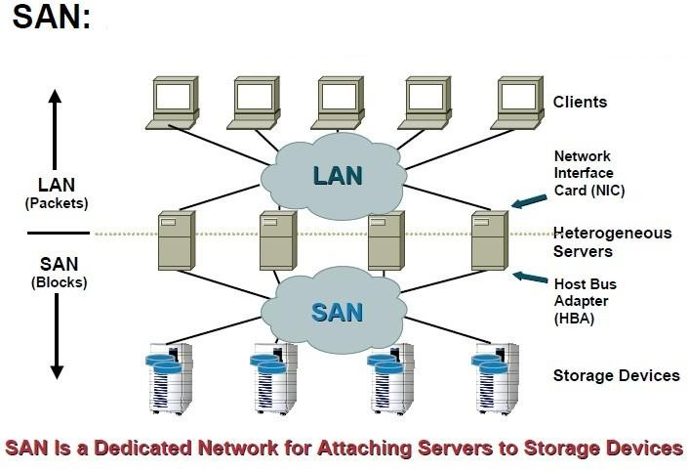

1

### Listed below are a few main features of SAN:

* + Provides block level access rather than file level access that is provided by NAS (Network Attached Storage).
  + Fiber channel is the primary media used with SAN.
  + SCSI is the main I/O protocol.
  + SAN storage appears to the computer as its own storage.
  + It can have excellent speeds and performance when used with fiber channel media.
  + Used primarily for higher performance block level data storage.

### Creating virtual SAN using Starwind;

Starwind is a software from the company Starwind Software Inc. Starwind is the software that eliminates any need in physical shared storage by basically “mirroring” internal hard disks and flash between hypervisor servers. There is less hardware to buy in general, consequently less money is spent on purchase and maintenance. The existing hardware is used with maximum efficiency, so there is no money wasted at all.

StarWind can be used as shared storage for almost any application. It is fully compatible with VMware, Hyper-V, or server clusters for applications such as SQL Server, Exchange, and SharePoint. Starwind Virtual SAN is the software meant for the people who want to build and maintain virtualization infrastructure at little to no expenses.

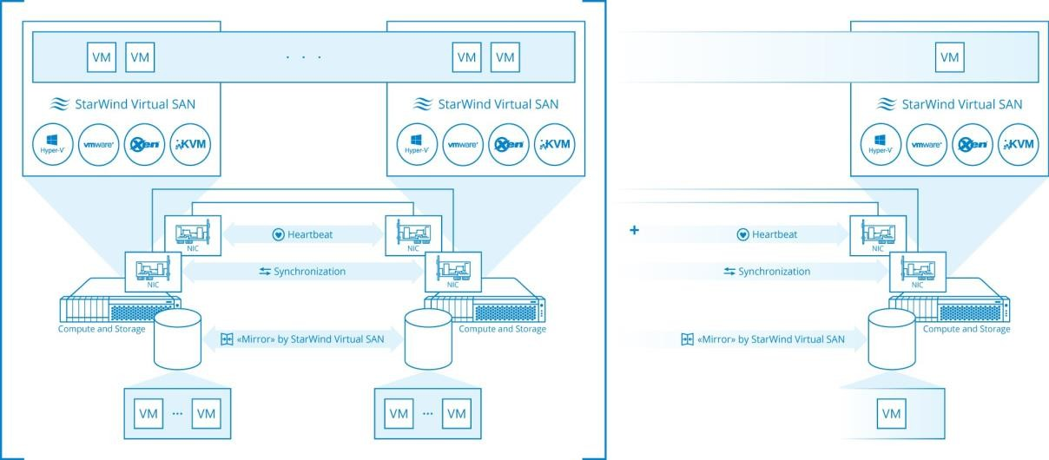

2

### Benefits of using Starwind Virtual SAN:

1. **Simplicity**: Simplicity is a key feature. StarWind Virtual SAN runs as a native

hypervisor component or in VM, and it does not require any deep storage and network

administration or UNIX management skills. A typical system administrator with minimal experience in Hyper-V, VMware or Windows can install, configure and maintain VSAN operations.

1. **Low cost:** StarWind Virtual SAN cuts the cost at least in half, meaning both Operational and Capital Expenditures. It eliminates the actual physical shared storage, corresponding infrastructure, as well as associated deployment and maintenance activities. StarWind VSAN works on commodity components, so there is not only less hardware to purchase and maintain, but also the required hardware is inexpensive.
2. **High performance**: Performance is uncompromised by the minimalistic hardware footprint, reduced deployment and management costs. StarWind Virtual SAN brings to the table server-side flash and memory caches, log-structuring and an absolutely minimalistic I/O path. The resulting performance is unmatched by either typical virtual appliances or physical shared storage.

### Step by step Procedure to create virtual SAN using Starwind:

* 1. **Installation of Starwind software.**

1. Download the setup file from [https://www.starwindsoftware.com/download-](https://www.starwindsoftware.com/download-starwind-products)

[starwind-products](https://www.starwindsoftware.com/download-starwind-products).

1. Launch the setup file downloaded in previous step on the server that we want to turn into SAN storage.
2. The setup wizard will start, click “Next”.
3. Read and accept the license agreement. Click “Next”.
4. The setup wizard will display some important information. Read it carefully and click “Next”.
5. Select the installation path by click the Browse button. Click “Next”.
6. Starwind offers three types of installations:

3

* 1. **Starwind iSCSI service**:- This installation type is applied to remote access servers. StarWind Service enables the creation of various devices (e.g. HA devices, Snapshot, CDP, and Mirror devices) and can be managed with StarWind Management Console from another computer.
  2. **StarWind Management Console**:- Management Console is the Graphical User Interface (GUI) part of the program that monitors and controls the storage related operations (e.g. allows for the creation of devices on the available target servers). After its installation, **Management Console** connects to **StarWind Service** remotely.
  3. **Full installation:-** Full installation includes both **StarWind Service** and **Management Console** elements. It allows for the management of resources from the machine with installed **StarWind Service**.

1. Select Full installation. Click “Next” to continue.
2. Specify the Start Menu Folder. Click “Next” to continue.
3. Select the checkbox if you want to create desktop icon for Starwind and Click “Next“ to continue.
4. If you are sure about the setting you have selected click “Install” to continue otherwise go back and make the desired changes.
5. After the installation process is complete, you will be prompted to apply either a time-limited fully functional evaluation key, or a FREE version key, or a fully unlocked commercial license key that is supplied with an acquired StarWind product. Select the appropriate option. Click “Next” to continue.
6. Select the appropriate checkbox to launch StarWind Management Console immediately.
7. Click “Finish” to close the wizard.

### Register the Software.

* + 1. Launch Starwind Management Console: double click stawind tray icon. The management console allows for the management of multiple Starwind servers from one computer.
    2. Activate Starwind Management Console by applying your License Key. Click “Apply Key” to proceed.
    3. Click “Load” to select and open the license file that you have received. Click “OK” to continue.
    4. The locally installed Starwind Service Server is listed in the servers item of the console tree. His is shown in the following screenshot:
    5. Click “Connect” in the toolbar to connect to the server.
    6. You will be prompted to enter the username and password. The default login and password are:

Username: root and password: starwind.

* + 1. Click “OK” to continue.

To Register Starwind Software:

* + 1. Select the connected server and go to the configuration tab.
    2. Click “Registration”. You will see the information about the license applied to this server.
    3. Click install to apply the license.
    4. Click “Load**”** to select and open the license file that you have received.
    5. Click “OK” to continue.

### Creating a basic virtual device:

* + 1. Select the server where a new virtual device will be created. Click “add device” in the toolbar. “Add device” wizard will appear.Follow the wizard steps to complete the creation of a new image file device.
    2. Go to Hard Disk -> Basic Virtual -> Image file device.
    3. Click “Next” to continue.
    4. Select the create new virtual disk option. See the following screenshot.
    5. Click “Next” to continue.
    6. Specify the location, name, and size of a virtual disk in the appropriate fields. Click “Next” to continue. See the following screenshot:
    7. If needed, set additional parameters for your virtual disk. Click “Help” to get detailed information. See the following screenshot:
    8. Click “Next” to continue.
    9. Set caching parameters for your device. (Select “Normal – No caching”). Click “Next” to continue.
    10. Select target attachment method. For a new target , specify the target alias and clustering option if required. See the following screenshot:
    11. Check the summary of the set options. Click “Next” to continue if you do not want make any changes.
    12. Click “Finish” to close the wizard.

### Accessing the virtual device from the client

**machine:**

1. On a client machine search for iSCSI Initiator setup.
2. Enter username and password.
3. Specify the IP address of the target machine.
4. Now right click “My Compuer” / “This PC”. Select “Manage”
5. Select “Disk Management”.
6. You are able to see the disk (virtual device) that you created before. Right Click and Select “Format”. Once you format the disk it becomes available for use on client machine.

**Conclusion:** A virtual hard plate of the necessary size is made on the Starwind server and got to on the customer machine.

|  |  |  |  |  |  |
| --- | --- | --- | --- | --- | --- |
| **Program Execution/ formation/ correction/ ethical practices**  **(07)** | **Documentation (02)** | **Punctuality (01)** | **Viva Answer (05)** | **Experiment Marks (15)** | **Teacher Signature with date** |
|  |  |  |  |  |  |

6

# Output

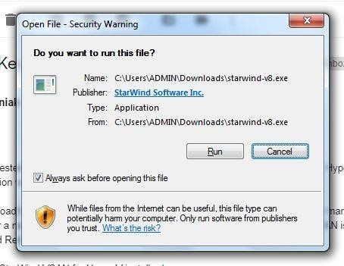

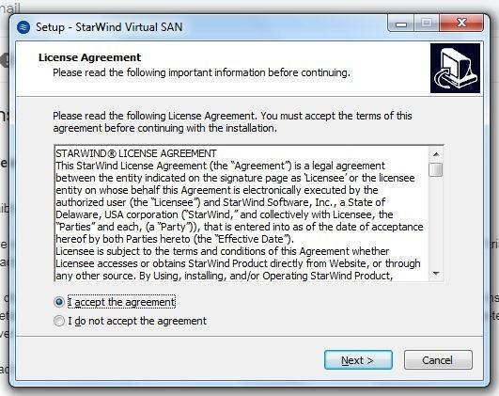

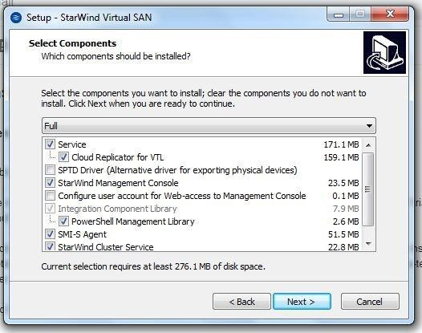

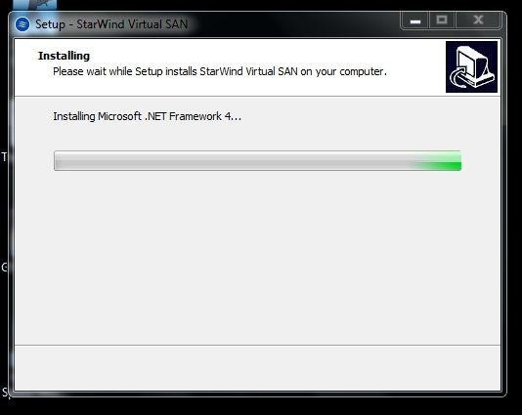

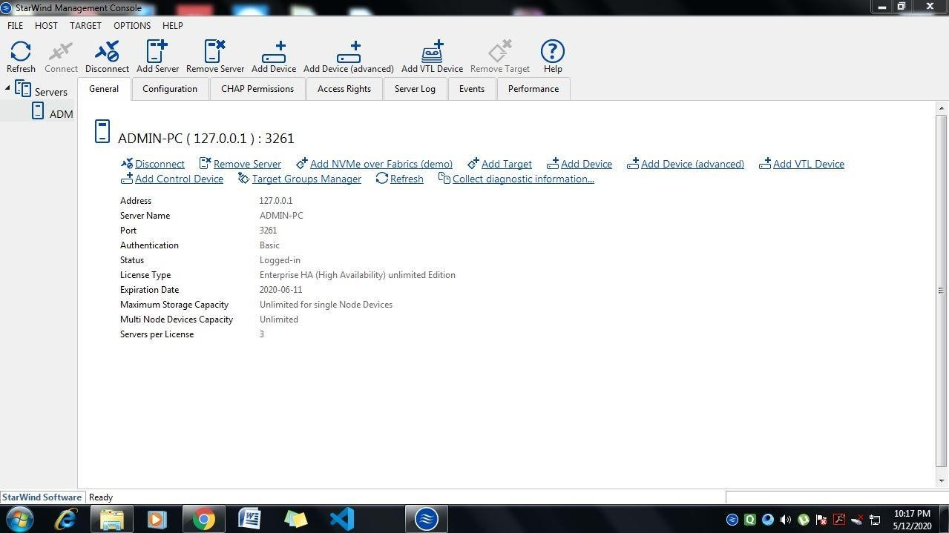

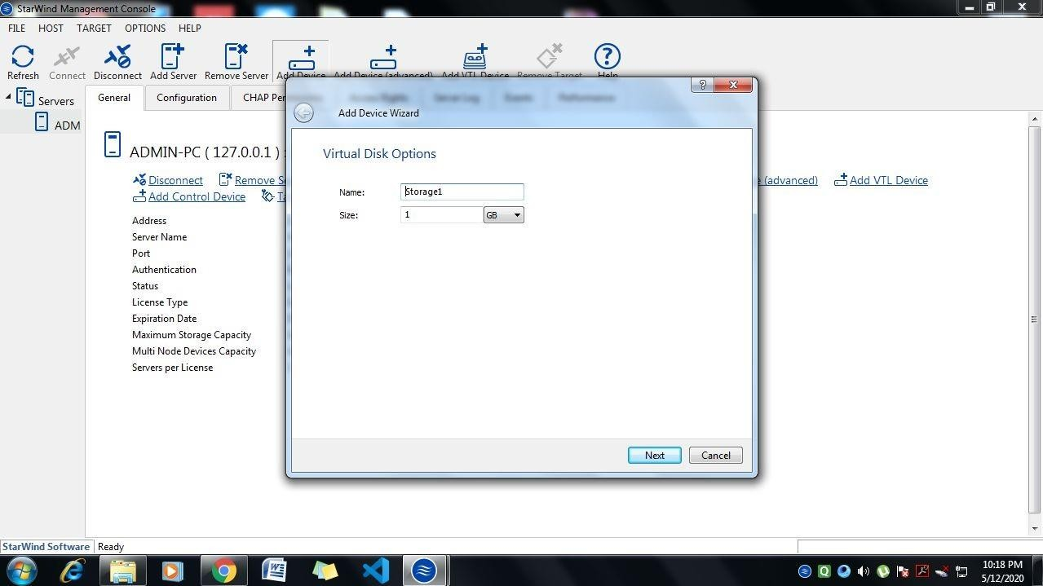

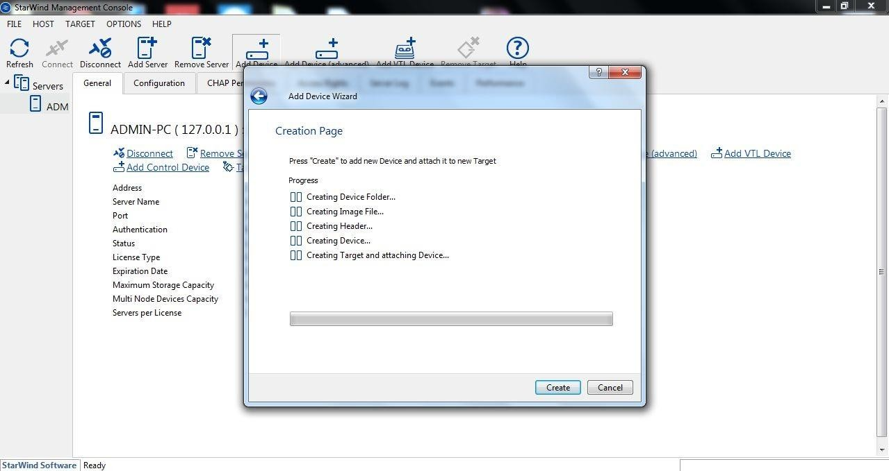

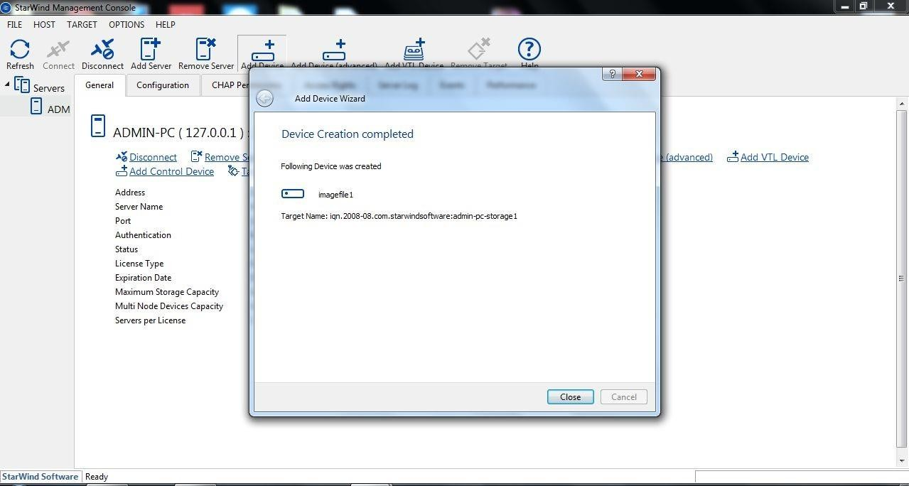

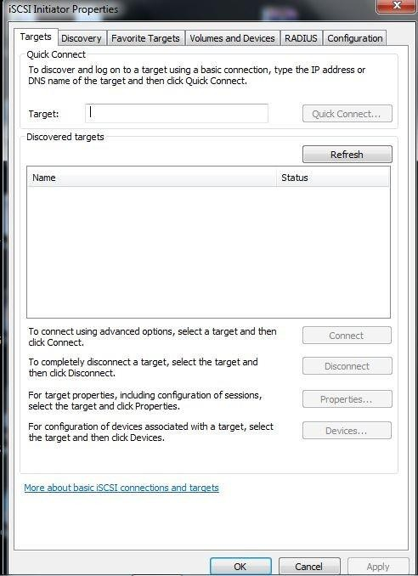

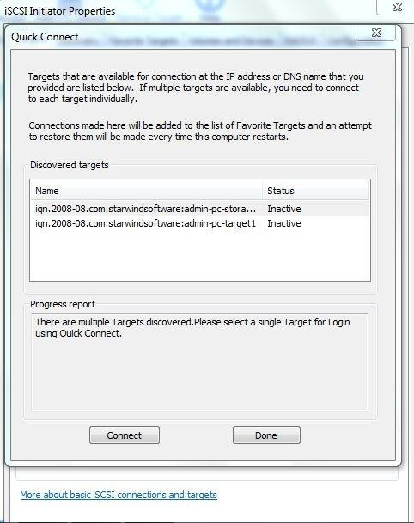

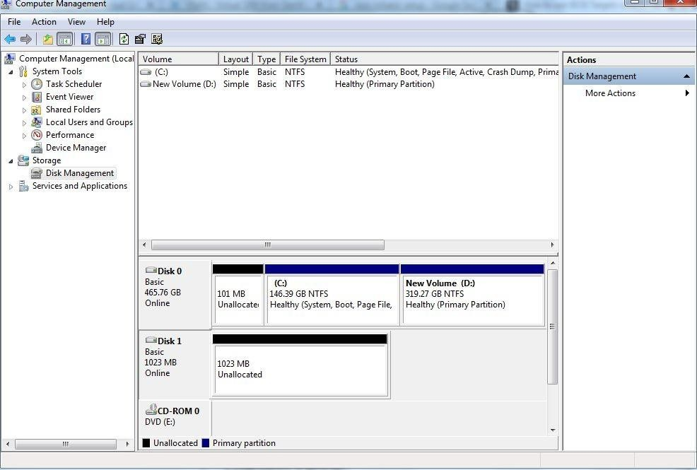

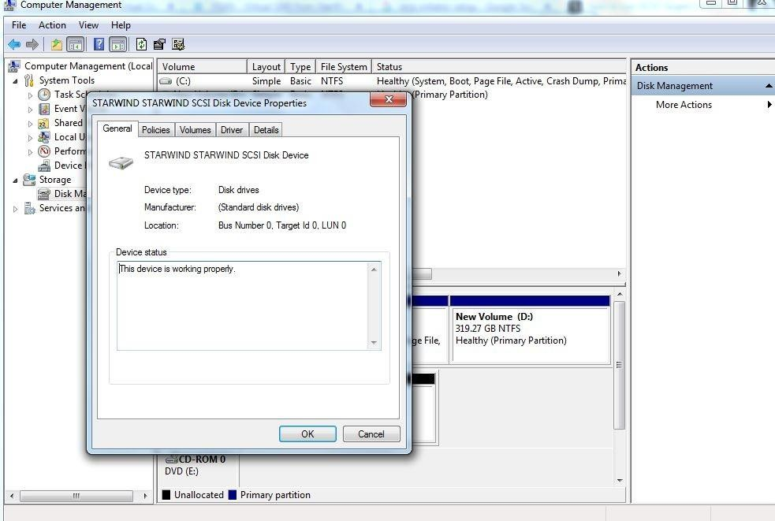

### Conclusion :

Here, we have made a virtual Storage Area Network (SAN) utilizing Starwind. StarWind conveys Software-Defined Storage arrangements, HyperConverged and Storage Appliances intended to fabricate profoundly strong IT frameworks. A capacity territory organize (SAN) is a protected rapid information move arrange that gives access to solidified square level stockpiling. A SAN makes a system of capacity gadgets open to numerous servers.

### Module 09

**Title:** Case Study on Fog Computing

**Objective:** To have a basic understanding of implementation/applications of fog computing.

### Theory:

Fog computing is a promising computing paradigm that extends cloud computing to the edge of networks. Similar to cloud computing but with distinct characteristics, fog computing faces new security and privacy challenges besides those inherited from cloud computing. Fog computing is introduced as an intermediate layer between the clients and the Cloud. It brings computing, storage, management, and network services among others, closer to the sensor/actuator nodes.

The Internet-of-Things (IoT) is a self-configuring and adaptive network which connects real- world things to the Internet enabling them to communicate with other connected objects leading to the realization of a new range of ubiquitous services.The IoT is already around us connecting wearable devices, smart cars and smart home systems. It is expected that more than 50 billion devices will be connected to the Internet by 2020

The introduction of such a huge number of connected devices requires a scalable architecture to accommodate them without any degradation of the quality of service demanded by applications. In addition, the majority of the devices that make up the Internet of Things are resource-constrained; resources, such as computing power, energy, bandwidth and storage are scarce. These constraints limit the deployment scenarios of applications using such IoT devicesFog computing layer brings computing, network and storage services closer to the end-nodes in IoT. Compared to Cloud computing, this computing layer is highly distributed and introduces additional services to end-devices located in the perception layer.

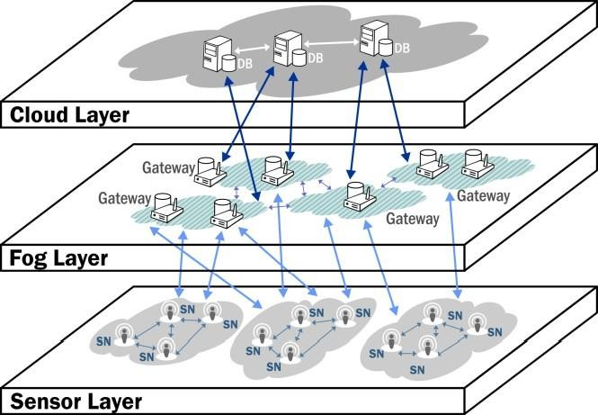

Fig. High level overview of fog based IoT

### Fog Computing Basics

The introduction of the IoT brings billions of devices to the Internet and the majority of these devices are resource-constrained. To overcome the challenges of these devices and meet the requirements of the application domain, the demand for an intermediate computing layer becomes evident. The concept of fog computing is the latest descendant in the line of physical separation of functional units. It is a computing layer closer to the perception layer, where the sensors and actuators reside, and provides computing, networking, and storage services.

### Characteristics of the Fog layer

In contrast to the Cloud layer, the Fog layer is closer to the perception layer and this proximity provides a range of advantages that characterise the layer. One of the immediate benefits over the Cloud is its location-awareness. Such awareness comes due to the largescale geographical distribution of the devices that make up the Fog layer. The location-awareness of the Fog layer can be utilized to address multiple functional and non-functional requirements of IoT applications, such as mobility and security. Another closely related characteristics of the Fog layer is its large scale distribution in contrast to the centralized

Cloud layer. Centralization in this context is relative; the Cloud layer is centralized as seen from the client side. Looking from the organization of the servers in the cloud, however, it is geographically distributed but not at the scale expected from the Fog layer. For instance, Cloud service providers such as Amazon have multiple data centers in different regions.The IoT in general is dominated by wireless networks. There are many wireless protocols, mostly tailored for low-power operation, coverage or bandwidth.

### Design and Organization of the Fog layer

Based on the characteristics of the Fog layer presented in the previous section and the possible set of services highlighted in the following section, the Fog layer can Chapter 1 Fog Computing Fundamentals in The Internet-of-Things 7 be organized in an efficient way to address the requirements. This section is by no means comprehensive and detailed enough for build a usable intermediate layer, but instead gives an introductory information that will be dealt in more details in later chapters. To begin with, consider a network gateway or a wireless hot-spot serving clients in its vicinity. The role of such a gateway is to pass network packets to the back-end infrastructure which is connected to the Internet

### Fog Computing Services

This layer takes advantage of its proximity to the sensor layer and provides services that are extensions of the cloud layer and also unique ones that are feasible only at this layer. This section gives an overview of a subset of possible services at the fog layer and the related advantages that enable IoT. These services are organized into Compute, Storage and Network services.

### Computing services

The limitations of computing power of the devices in the perception layer has led to the introduction of remote processing approaches. Processing at the Fog layer is not only motivated by the constraint of processing power at sensor nodes, but also by the desired location of computing to better meet system requirements and maintain energy efficiency.

### Storage Services

A huge amount of data can be generated by the sensor nodes and there are billions of these sensor devices around. The storage available in the devices at the perception layer is not often sufficient to store even a one-day data considering the rate of data generation. Combined with the computing service, the stored data can

be filtered, analyzed, and compressed for efficient transmission or for learning local information regarding the system behaviour. In cases where the communication may not be robust, the storage services help enhance the reliability of the system by maintaining proper system behavior for client nodes.

### Communication Services

The communication in the Internet-of-Things is dominated by wireless nodes. Due to the resource constraints in the perception layer, these wireless protocols are optimized for low power operation, narrow-band transmission or longer range of coverage. Currently, a long list of alternative protocols are available in the market. This helps in managing sub-networks of sensors and actuators providing security, channeling messages among devices and enhancing the reliability of the system. In addition, this layer can provide interoperability of disparate protocols by listing and interpreting the representation format. Moreover, the Fog layer provides visibility of devices that are non-IP-based to be accessible through the Internet.

### Conclusion:

Haze processing is a promising registering worldview that stretches out distributed computing to the edge of systems. Like distributed computing however with particular qualities, mist processing faces new security and protection challenges other than those acquired from distributed computing.

|  |  |  |  |  |  |
| --- | --- | --- | --- | --- | --- |
| **Program Execution/ formation/ correction/ ethical practices**  **(07)** | **Documentation (02)** | **Punctuality (01)** | **Viva Answer (05)** | **Experiment Marks (15)** | **Teacher Signature with date** |
|  |  |  |  |  |  |

# Output

**Definition:**

**Fog Computing**

Fog computing refers to a decentralized computing structure, where resources, including the data and applications, get placed in logical locations between the data source and the cloud. It is also known by the terms ‘fogging’ and ‘fog networking.’ The goal of this is to bring basic analytic services to the network edge, improving performance by positioning computing resources closer to where they are needed, thereby reducing the distance that data needs to be transported on the network, improving overall network efficiency and performance. Any device with computing, storage, and network connectivity can be a fog node. Examples include industrial controllers, switches, routers, embedded servers, and video surveillance cameras. Fog computing can also be deployed for security reasons, as it has the ability to segment bandwidth traffic, and introduce additional firewalls to a network for higher security.

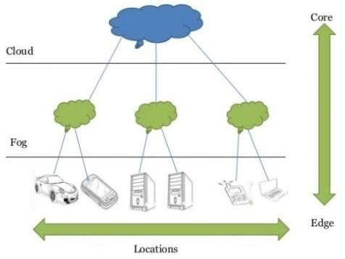

# Characteristics:

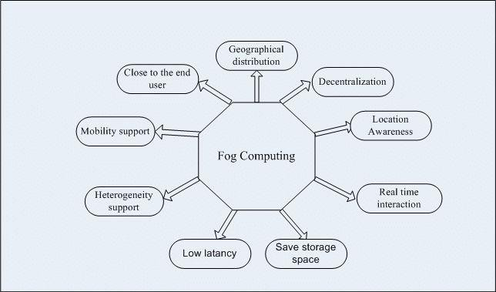

**Services:**

**Communication Service:** The communication in the Internet-of-Things is dominated by wireless nodes. Due to the resource constraints in the perception layer, these wireless protocols are optimized for low power operation, narrow-band transmission or longer range of coverage.

**Storage Service:** A huge amount of data can be generated by the sensor nodes and there are billions of these sensor devices around. The storage available in the devices at the perception layer is not often sufficient to store even a one-day data considering the rate of data generation.

**Computing Service:** The limitations of computing power of the devices in the perception layer has led to the introduction of remote processing approaches. Processing at the Fog layer is not only motivated by the constraint of processing power at sensor nodes, but also by the desired location of computing to better meet system requirements and maintain energy efficiency.

# Advantages:

* Better Security
* Lower Operational Costs
* Save Bandwidth Latency
* Better Privacy
* Easy To Develop Fog Applications

# Disadvantages :

* More Difficult For Arbitrary Devices
* Security Issues
* More Efforts For Data Consistency
* Trust and authentication are major concerns
* Complex Scheduling

# Conclusion :

In this we have learns about what is mist registering. It alludes to a decentralized registering structure, where assets, including the information and applications, get set in consistent areas between the information source and the cloud. It is likewise known by the terms 'misting' and 'mist organizing. Just as we have learns about qualities , administrations gave by mist registering and furthermore its points of interest and disservices